

REPLANNER GUIDELINE BLUEPRINT

**JOB TITLE**

**REPLANNER**

**MODULE**

**REPLANNER COURSE**

**(Course Code: XXXXX**

**Version: 1.0**

**Date: February 2026)**

**Name of Trainee :**

**NRIC/FIN No. :**

**Company Name/Department : Course Start Date :**

**Course End Date :**

**© PSA Corporation Limited. Year 2015. Printed in Singapore. All rights reserved. Please note that information contained in these training materials are strictly confidential and may not be revealed to any third parties, reproduced, stored in a retrieval system nor transmitted in any form or by any means (electronic, mechanical, photocopying, recording, or otherwise) without the prior written consent of PSA Corporation Limited.**

|  |  |  |
| --- | --- | --- |
| REPLANNER | | Handout Ref No. |
| Action | Name | Date |
| Drafted by: |  |  |
| Vetted by: |  |  |
| Approved by: |  |  |

# Introduction

The container terminal operates round-the-clock and the Automated Yard Duty Manager (aYDM) manages the terminal yard operations during shift. The Replanner (RP) assist the aYDM by ensuring that yard operations within section are carried out smoothly, efficiently and safely whilst meeting Operational targets. Important RP targets include ensuring good Prime Move (PM) productivity via good yard waiting time.

# Objective

The objective of this OJT programme is to enable the RP to:

1. Familiarize himself with the roles and responsibilities of the RP
2. To learn and understand the skills required for him to function effectively and independently in his role as an RP
3. To be aware of the operational situations faced in the Container Terminal and how to make correct decisions to achieve the best yard performance possible

# Tasks

During his training programme, the trainee will observe his mentor carrying out his RP duties, which can include the following:

1. Monitoring of yard service level and productivity
2. Monitoring and minimizing yard congestion (RTGs, ARMGs)
3. Handling common yard exceptions
4. Execute smooth shift changeover

With guidance from his Shift Mentor, he should use the guidelines / knowledge checklist to gauge the extent of his knowledge gained. RP should prepare himself to perform the role independently in the future by asking questions actively during OJT to better equip himself with the required skills.

The Section AM will review his assignments and assess his understanding using the Guidelines / Knowledge Checklist. The complete Task Book will be used as a record to determine if the trainee has attained the necessary competencies.

**REPLANNER GUIDELINE CURRICULUM**

|  |  |  |  |
| --- | --- | --- | --- |
| **JOB TITLE:** Replanner | | **SECTION:** P4-P56SE | |
| **DEPARTMENT:** Yard Operation Department | | **DIVISION:** Container Division | |
| **OJT MODULE:** Replanner Course | | **TOTAL TASKS:** 10 | **TOTAL OJT HOURS:** 262 |
| **S/N** | **TASKS** | | **OJT HOURS** |
| 1 | Perform Basic Terminal Operations and Monitor Yard Key Performance Indicators (KPI) | | 12 |
| 2 | Identify Yard Layout and Equipment | | 24 |
| 3 | Use of UHF set and CCTV for Operations | | 12 |
| 4 | Use of Systems for Operations | | 36 |
| 5 | Gantry of RTGs and Yard Safety SOPs | | 12 |
| 6 | Monitor Yard Operations and Equipment | | 36 |
| 7 | Forecast Yard Activities and Equipment Positioning | | 12 |
| 8 | Prime Mover (PM) Diversions SOP | | 36 |
| 9 | Handle and Escalate different Yard Exceptions | | 12 |
| 10 | YPD attachment (After 1 month’s experience) | | 36 |

# Task 1: Perform Basic Terminal Operations and Monitor Yard Key Performance Indicators (KPI)

* 1. **: Perform Basic Terminal Operations**

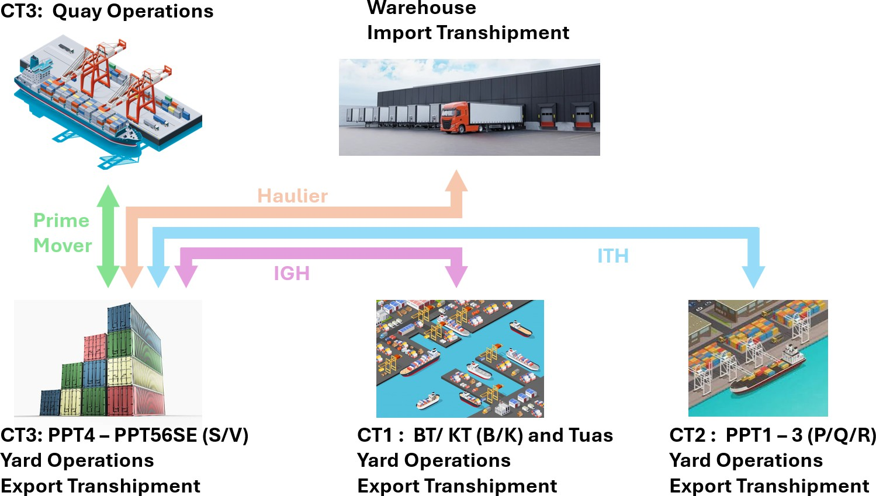

**Legends:**

**CT: Container Terminal K: Keppel**

**B: Brani**

**ITH: Inter-Terminal Haulage IGH: Inter-Gateway Haulage**

* 1. **: Operations Contact List:**

|  |  |
| --- | --- |
| **PPT4 – PPT56SE Yard Operation Teams** | |
| **Roles:** | **Tel:** |
| **PPT4 AAOC** | **6731 (AAOC) / (Radioset: PPT5 AOC-1)** |
| **PPT5 AOC / AAOC** | **6508 (AOC) / 6526 (AAOC) / (Radioset: PPT5 AOC-1)** |
| **PPT6 AOC / AAOC** | **7908 (AOC / AAOC) (Radioset: PPT6 AOC-1)** |
| **aYDM 4** | **6738 (HP: 82234074)** |
| **aYDM 5 / 6** | **6813 / 6817** |
| **YSS** | **6725 / (Radioset: CT3 Yard-Ops)** |
| **YPDM** | **6601** |
| **Reefer Yard IC** | **6613 / 6607** |
| **Reefer Repair** | **6265 7535** |

|  |  |  |  |
| --- | --- | --- | --- |
| **PPT4 – PPT56SE Ship Operation Teams** | | | |
| **Department / Section:** | **Roles:** | **Berth:** | **Tel:** |
| **PPT4** | **TDM 4** | **P27 – P29** | **6450 / (HP: 97326782)** |
| **TOC 4** | **6281** |
| **VOC 4A** | **6449** |
| **VOC 4 B** | **6819** |
| **PP56SE** | **TDM 5 / 6** | **P30 – P41** | **6509** |
| **TOC 1** | **P30 – P34** | **6810** |
| **SDM A** | **6501 / (HP: 96363771)** |
| **VOC 1** | **P30 – P31** | **6502** |
| **VOC2** | **P32 – P34** | **6733** |
| **TOC 2** | **P35 – P41** | **6739** |
| **SDM B** | **P35 – P38** | **6723 / (HP: 98308127)** |
| **SDM C** | **P39 – P41** | **6812 / (HP: 97399078)** |
| **VOC 3** | **P35 – P36** | **6721** |
| **VOC 4** | **P37 – P38** | **6555** |
| **VOC 5** | **P39 – P41** | **6507** |

|  |  |  |
| --- | --- | --- |
| **CT2 PPT1-3 Ship / Yard Operation Teams** | | |
| **Roles:** | **Berth:** | **Tel:** |
| **TDM 1** | **P01 – P06** | **7721 (PPT 1)** |
| **TDM 2** | **P07 – P11 / P23 – P26** | **7722 (PPT 2)** |
| **TDM 3** | **P15 – P22** | **7723 (PPT 3)** |
| **YDM** | **--** | **7570 (YARD)** |
| **HYSTER** | **--** | **7576 (YARD)** |
| **OHBC** | **--** | **7558 (YARD)** |

|  |  |  |  |  |
| --- | --- | --- | --- | --- |
| **Others:** |  |  | **Resource:** | |
| **Roles:** | **Tel:** | **Roles:** | **Tel:** |
| **ITT** | **6291** | **Logistics** | **6539** |
| **IGH** | **6710 / 6711 / 6713** | **PMOC** | **6401** |
| **IT Helpdesk** | **5459 / 1580** | **APM Controller** | **6541 / (Radioset: 680101)** |
| **Gate IC** | **6308 / 6309 / 6320** |  | | |
| **CHEMCARE** | **96175895** |
| **SRDO** | **6964 / (HP: 98245715)** |
| **Emergency (ERT)** | **7730** |

* 1. **: Hourly Yard Wait Time Ship Ops:**

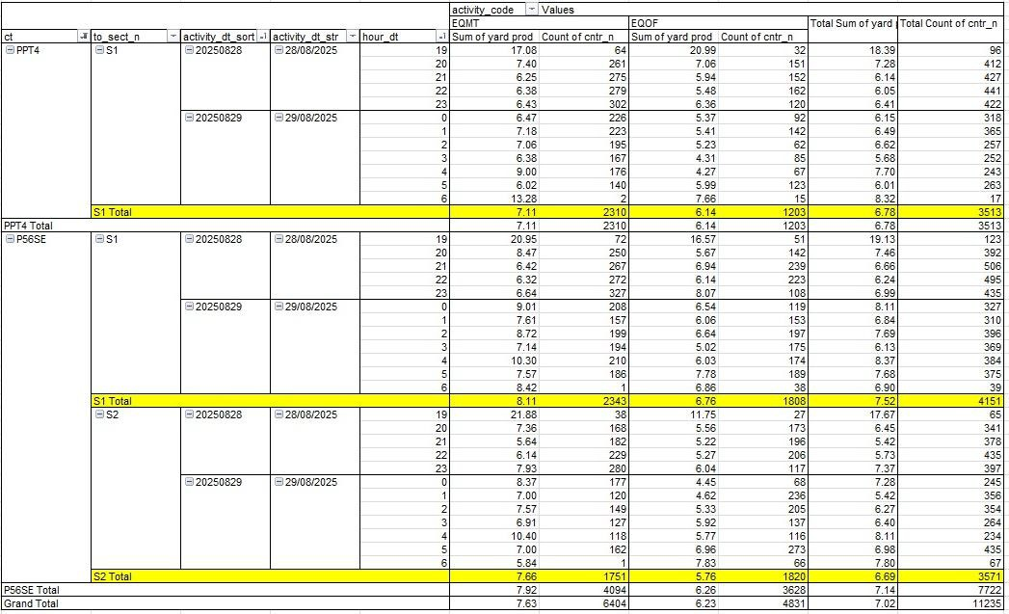

# Task 2: Identify Yard Layout and Equipment

* 1. **: Yard Layout**

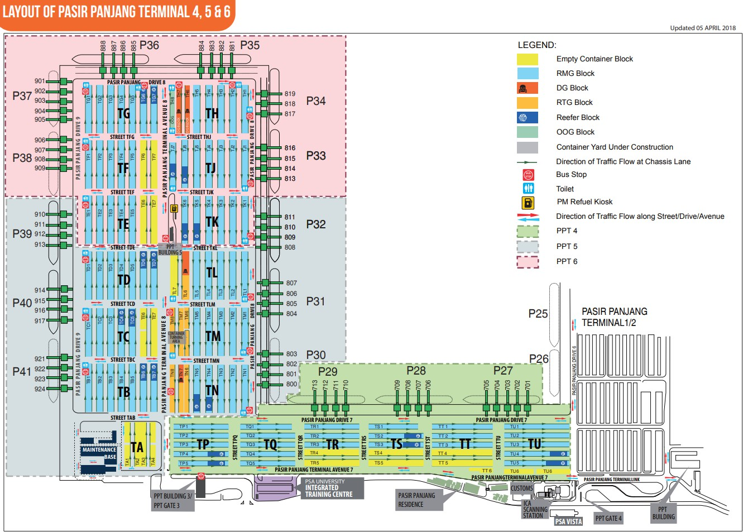

# A group of containers in a port AI-generated content may be incorrect.A large group of containers in a port AI-generated content may be incorrect.A large group of trucks in a warehouse AI-generated content may be incorrect.A large crane with many containers AI-generated content may be incorrect.: Equipment’s Layout and Special Stowage Area

|  |  |
| --- | --- |
| **LOCATIONS OF RTG BLOCKS** | |
| **Terminal P4** | |
| **Section** | **Block** |
| Section 1 | TR04 |
| TS04 |
| TS05 |
| TT04 |

|  |  |
| --- | --- |
|  | |
|  | PPT4 RTG Block |

|  |  |
| --- | --- |
| **LOCATIONS OF RTG/ERTG BLOCKS** | |
| **Terminal P56SE** | |
| **Section** | **Block** |
| Section 1 | TL06 |
| TM07 |
| TN07 |
| TM08 |
|  |  |
| Section 2 | TH06 |
| TH07 |
| TH08 |

|  |  |
| --- | --- |
|  | |
|  | PPT5 RTG Block |

|  |  |
| --- | --- |
|  | |
|  | PPT6 ERTG Block |

|  |  |
| --- | --- |
| **LOCATIONS OF OH BLOCKS** | |
| **Terminal P56SE** | |
| **Section** | **Block** |
| Section 1 | TM06 |
| TN06 |
| TN08 |

|  |  |
| --- | --- |
|  | |
|  | PPT5 OH Block |

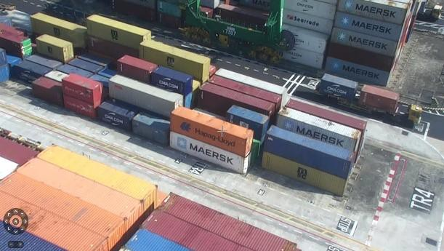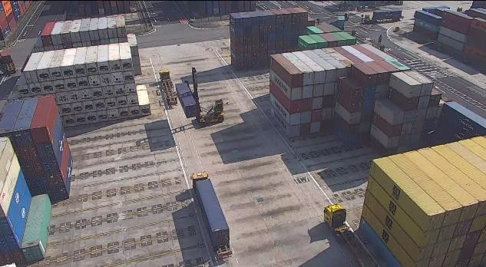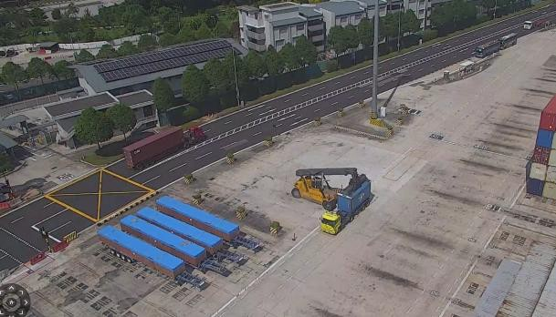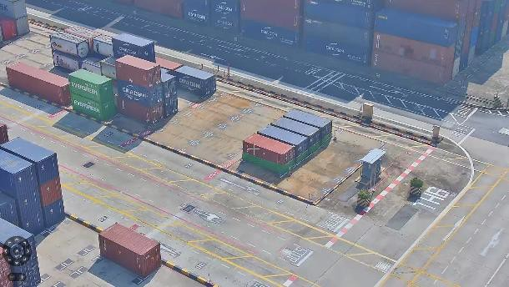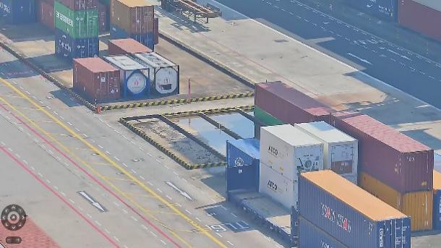

|  |  |
| --- | --- |
|  | |
|  | Damaged Yard |

|  |  |
| --- | --- |
|  | |
|  | Door Turning |

|  |  |
| --- | --- |
|  | |
|  | Bund Area |

|  |  |  |  |  |
| --- | --- | --- | --- | --- |
| **LOCATIONS OF FM BLOCKS** | | | | |
| **Terminal P4** | |  | **Terminal P56SE** | |
| **Section** | **Block** | **Section** | **Block** |
| Section 1 | TA01 | Section 1 | TC06 |
| TA02 | TC07 |
| TA03 | TL07 |
| TA04 |  | |
| TR06 | Section 2 | TE06 |
| TS06 | TE07 |
| TT06 | TF06 |
| TU06 | TF07 |

|  |  |
| --- | --- |
|  | |
|  | HYSTER BLOCK |

|  |  |
| --- | --- |
| **OTHERS:** | |
| **Terminal P4 - P56SE** | |
| **Yard Description** | **Block** |
| Damaged Yard Area | TR04 Slot 26 to Slot 37 |
| Door Turning Area | TT07 (Reach Stacker) |
| Jammed Cone Area | TL99 (TP01 Lane 0) |
| Bund Area | TL06 Slot 13 to Slot 14 |
| DG Reworking Area | TH06 Slot 35-36 |
| Haulier OOGs Chassis Parking Area | TL02, TM02 & TK02 (Lane 11) TL03, TM03 & TK03 (Lane 0) |

|  |  |
| --- | --- |
|  | |
|  | DG Reworking |

# : Basic Equipment Specifications

* + 1. **: Prime Mover (PM)**

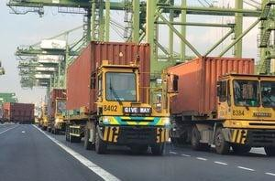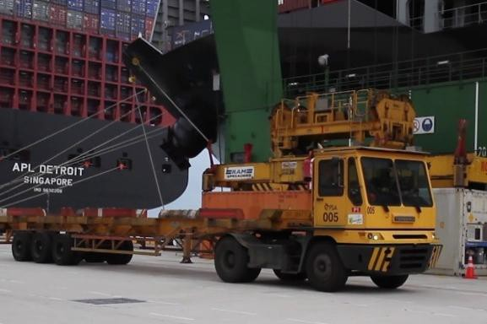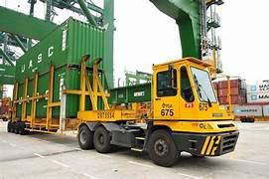Which transport container from one location to another for ship operation and yard operation (IGH, ITH and IYS).

|  |  |
| --- | --- |
|  | |
| APM |  |

|  |  |
| --- | --- |
|  | |
| CST |  |

|  |  |
| --- | --- |
|  | |
| DST |  |

# : Rail Mounted Gantry (RTG)

Located at RTG yard, handling both laden and unladen containers. Handle by operator manually during mounting and offloading of containers.

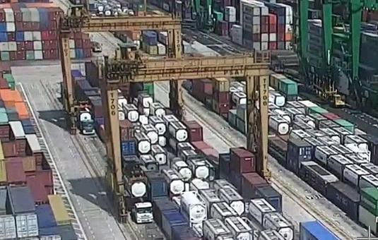

PPT4 RTG

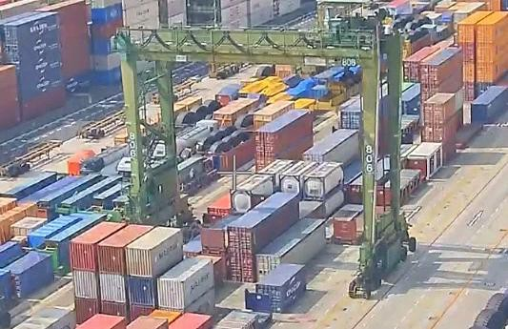

PPT5/6 RTG

# : Automated Rail Mounted Gantry (ARMG)

Located at ARMG yard, handling both laden and unladen containers. Fully automated during mounting and offloading of containers.

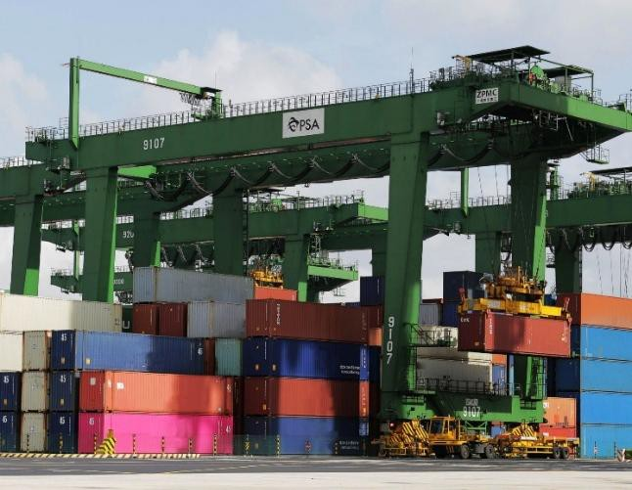

ARMG

# : Hyster / FM / Reach Stacker

Located at hyster yard, FM handling empty containers only and reach stacker handling both laden and empty containers. Each equipment is handled by operator manually during mounting and offloading of containers. Door turning operation will be done by reach stacker using CST prime mover only.

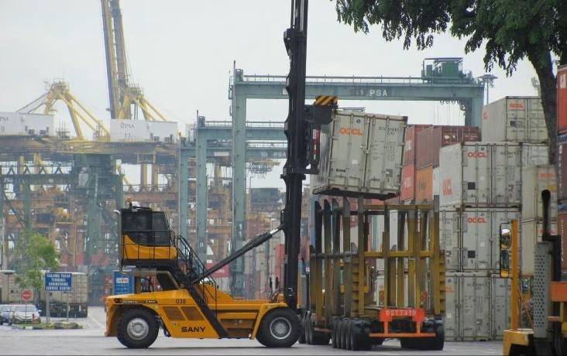

FM

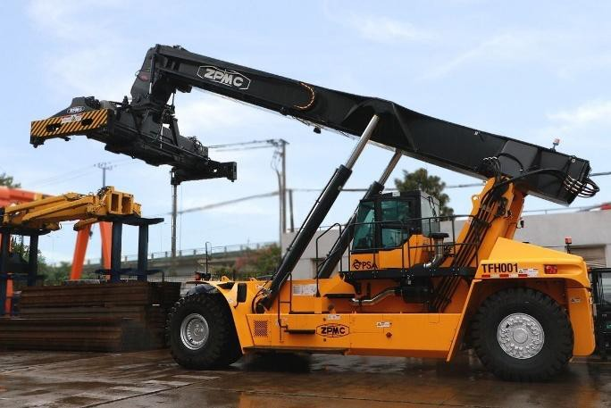

Reach Stacker

* 1. **: Common Container Types**

|  |  |  |  |  |
| --- | --- | --- | --- | --- |
|  |  |  | |  |
| **Dry Containers (GP / HC)** | **Reefer Containers (RF)** | **Open Top Containers (OT)** | |
| Suitable for dry cargo. | Suitable for temperature-controlled cargo. Mainly used for food items. | Suitable for over-height cargo. | |
| Sizes: 20ft / 40ft / 45ft | Sizes: 20ft / 40ft | Sizes: 20ft / 40ft | |
|  | | | | |
|  |  |  | | |
|  |  | |
| **Flat Rack Containers (FR)** | **ISO Tank Containers** |
| Suitable for project / oversized cargo. | Suitable for liquid products/ |
| **Common ISO Container Size and Type Codes** | |
| Sizes: 20ft / 40ft | Sizes: 21,000L / 24,000L / 25,000L / 26,000L |
|  | | |

**Task 3: Use of UHF set and CCTV for Operations**

* 1. **: Communication**

Effective communication in the yard requires quick and clear identification of equipment. Each radio set number is assigned using a standard format to indicate both the equipment type and the individual unit. Radio set numbers are made up of a three-digit prefix that represents the equipment type and follows the crane or prime mover number. Examples in table form as follows,

|  |  |  |  |
| --- | --- | --- | --- |
| **Equipment Type** | **Radio Set Prefix** | **Example (Crane/PM)** | **Radio Set Number** |
| Prime Mover (PPM) | 460 / 4600 | 429 | 460429 |
| Quay Crane | 610 | 710 | 610710 |
| RTG | 620 | 701 | 620501 |
| IGH (IPM) | 960 / 9600 | 989 | 960989 |
| FM / Hyster | 650 | 831 | 650831 |
| Reach Stacker | 651 | 802 | 651802 |

Besides using private call equipment through radio sets, alternative ways to communicate was to communicate inside the equipment block channel.

|  |  |  |  |  |  |  |  |  |  |
| --- | --- | --- | --- | --- | --- | --- | --- | --- | --- |
| **RTG Block Channels** | |  | **Useful Radio Set Channels** | | |  | **Useful Radio Set Channels** | | |
| **Terminal P4** | | **Vessel Control** | | | **Others** | | |
| **Folder** | **Channel** | **Description** | **Folder** | **Channel** | **Description** | **Folder** | **Channel** |
| PPYD OTHERS | TR / 4-5 | PQC701 – PQC713 | PPT4 Control | PPT4 SOC 1 | Replanner / IYS | PPT5 / PPT6  Control | CT3 YARD OPS |
| TS / 4-5 | PQC800 – PQC819 | PPT5 Control | PPT5 SOC 1 | Reefer Control | CT3 RF |
| PPYD TP-TU | TT / 4-5 | PQC881 – PQC888 | PPT6 Control | PPT6 SOC 1 | Hyster Block | PPYD OTHERS | CT3 Hyster |
|  | | PQC901 – PQC924 |  | | | |
| **Terminal P5** | | **ARMG Blocks** | | |
| PPYD OTHERS | TL / 6 | PPT4 ARMG Blocks | PPT5 Control | PPT5 AOC 1 |
| TM-TN / 6-8 | PPT5 ARMG Blocks |
|  | | PPT6 ARMG Blocks | PPT6 Control | PPT6 AOC 1 |
| **Terminal P6** | | **APM Control** | | |
| PPYD OTHERS | TH / 6-8 | APM Deploy IYS APM Deploy Ship Ops | PPT6 Control PPT5 Control | PPT6 AOC 2  PPT5 AOC 2 |

# : Yard CCTV

**Milestone Layout (Camera Grouping)**

**ARMG Block Cameras:**

Under Yard Folders

**RTG / Hyster Block Cameras:** Under Lighting Mast Folders

VMS 4

**JIT, BR, PPR**

* JIT
* PPR1
* BR

VMS 3

**PPT5, PPT6**

* Buildings
  + Substation
* Perimeter
* Lighting Mast
* Wharf
* WOS
* Yard

VMS 2

**PPT4, PPT5**

* Buildings
  + PITC
  + PPTB3
  + PPTMB
  + PPT RS
  + Substation
* Perimeter
* Lighting Mast
* Wharf
* WOS
* Yard

VMS 1

**PPT4, PPT6**

* Buildings
  + PPT5B
  + Substation
* Perimeter
* Lighting Mast
* Wharf
* WOS
* Yard

Main VMS

**Task 4: Use of Systems for Operations**

* 1. **: CITIS**
     1. **: Enquiry of Container Information (ENQC)**

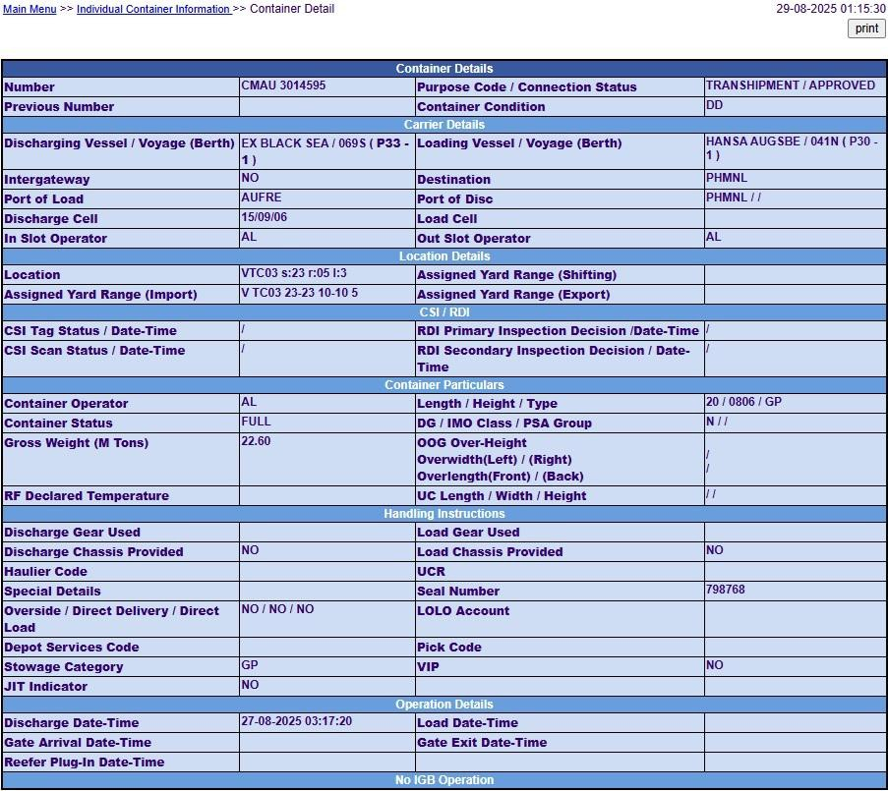

# : Yard Stack Enquiry (YART)

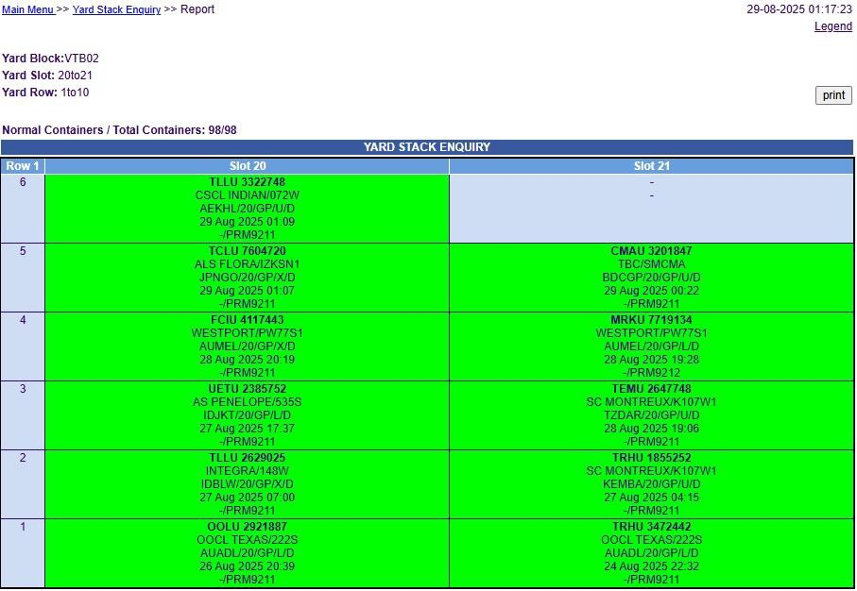

# : Container History (YMCN)

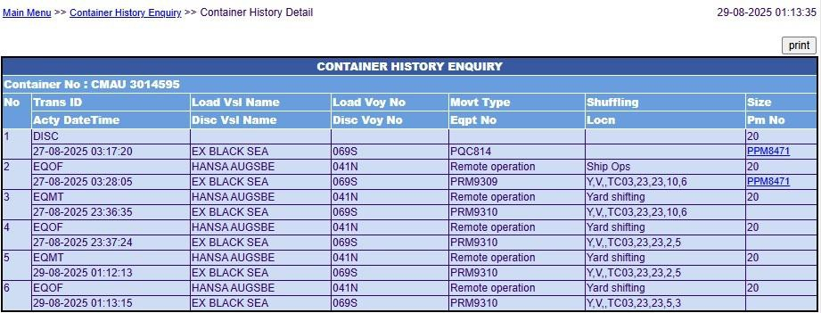

# : CITOS

# : Yard Planning System (YPS) Logical Yard:

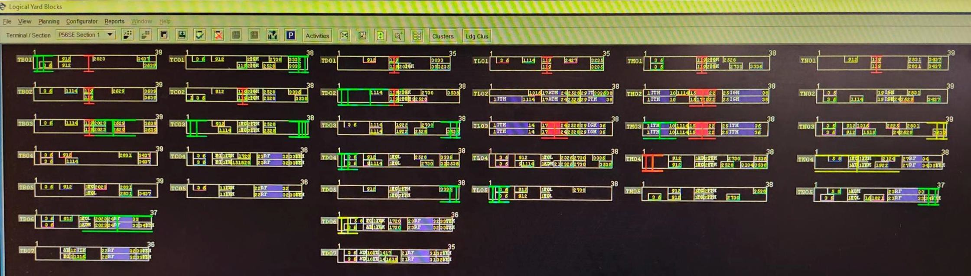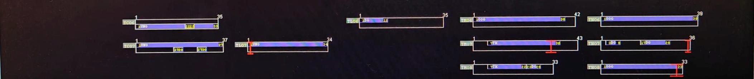

**MicroPlan View Mode: Blocks or Cluster**

**Enhance Activity**

Block View for RTG Block

Block View for Hyster Block

Block View for ARMG Block

**Enhance Activity:**

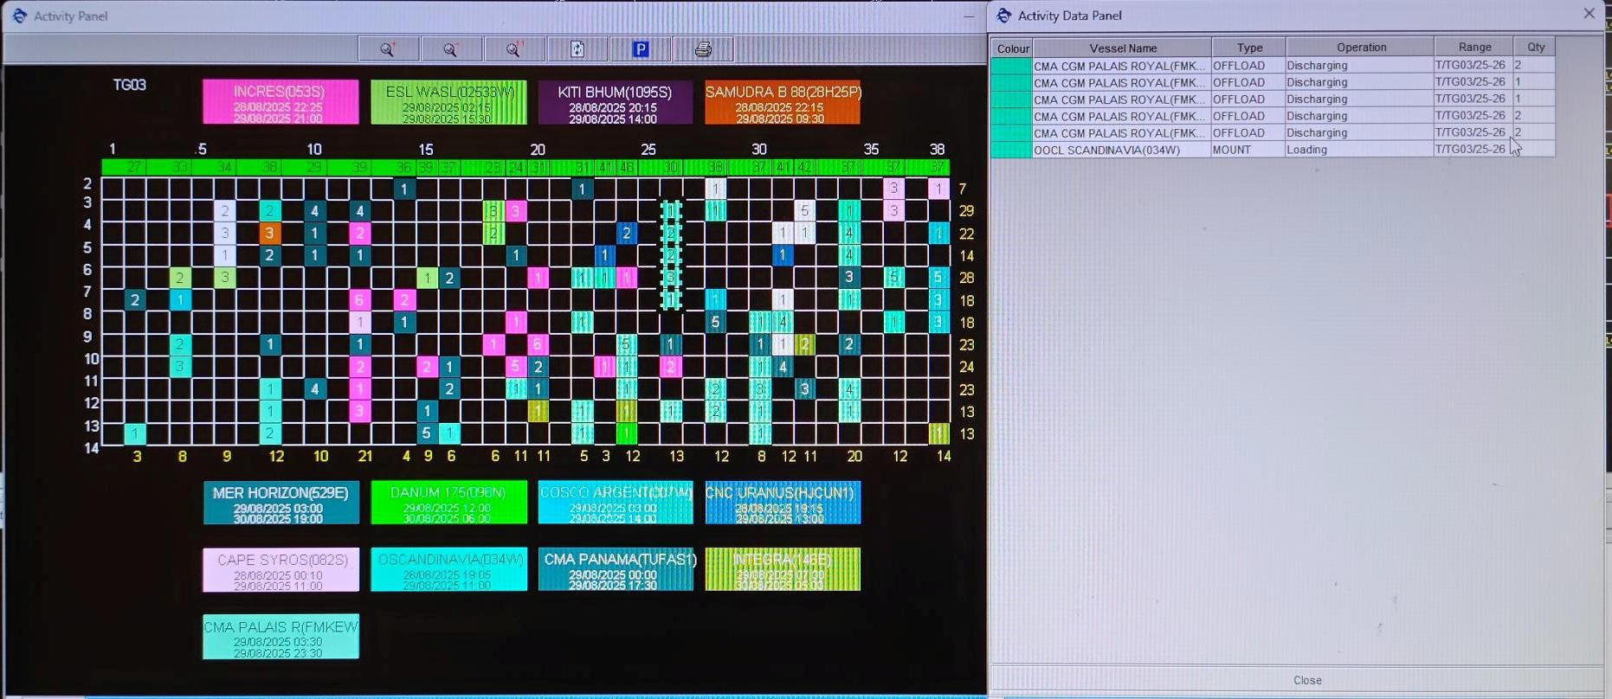

# : Yard QCC Panel Basic Knowledge:

|  |
| --- |
| Differentiate Vessel by Colour Coding |
| Current Yard Crane Position |
| Slot Number |
| Total Number of Containers |
| Total Number of Containers within the Slot |

Filter the Type of Activities

Time

BLK: P4-P56SE Blocks

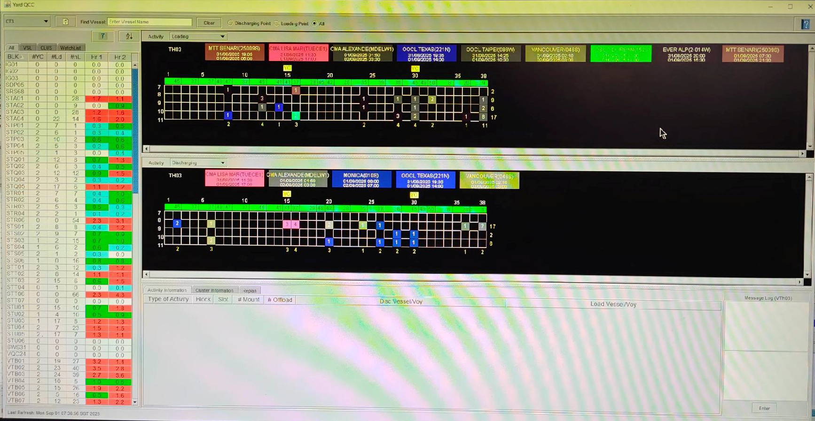

#YC: Number of Equipment’s (ARMGs, RTGs, Hyster)

#Ld: Number of Discharging Containers #nL: Number of Loading Containers

Hr 1: Activities Level within First Hour

Hr 2: Activities Level within Second Hour

# Example Forecast Activities at TH04 (Before and After Replan):

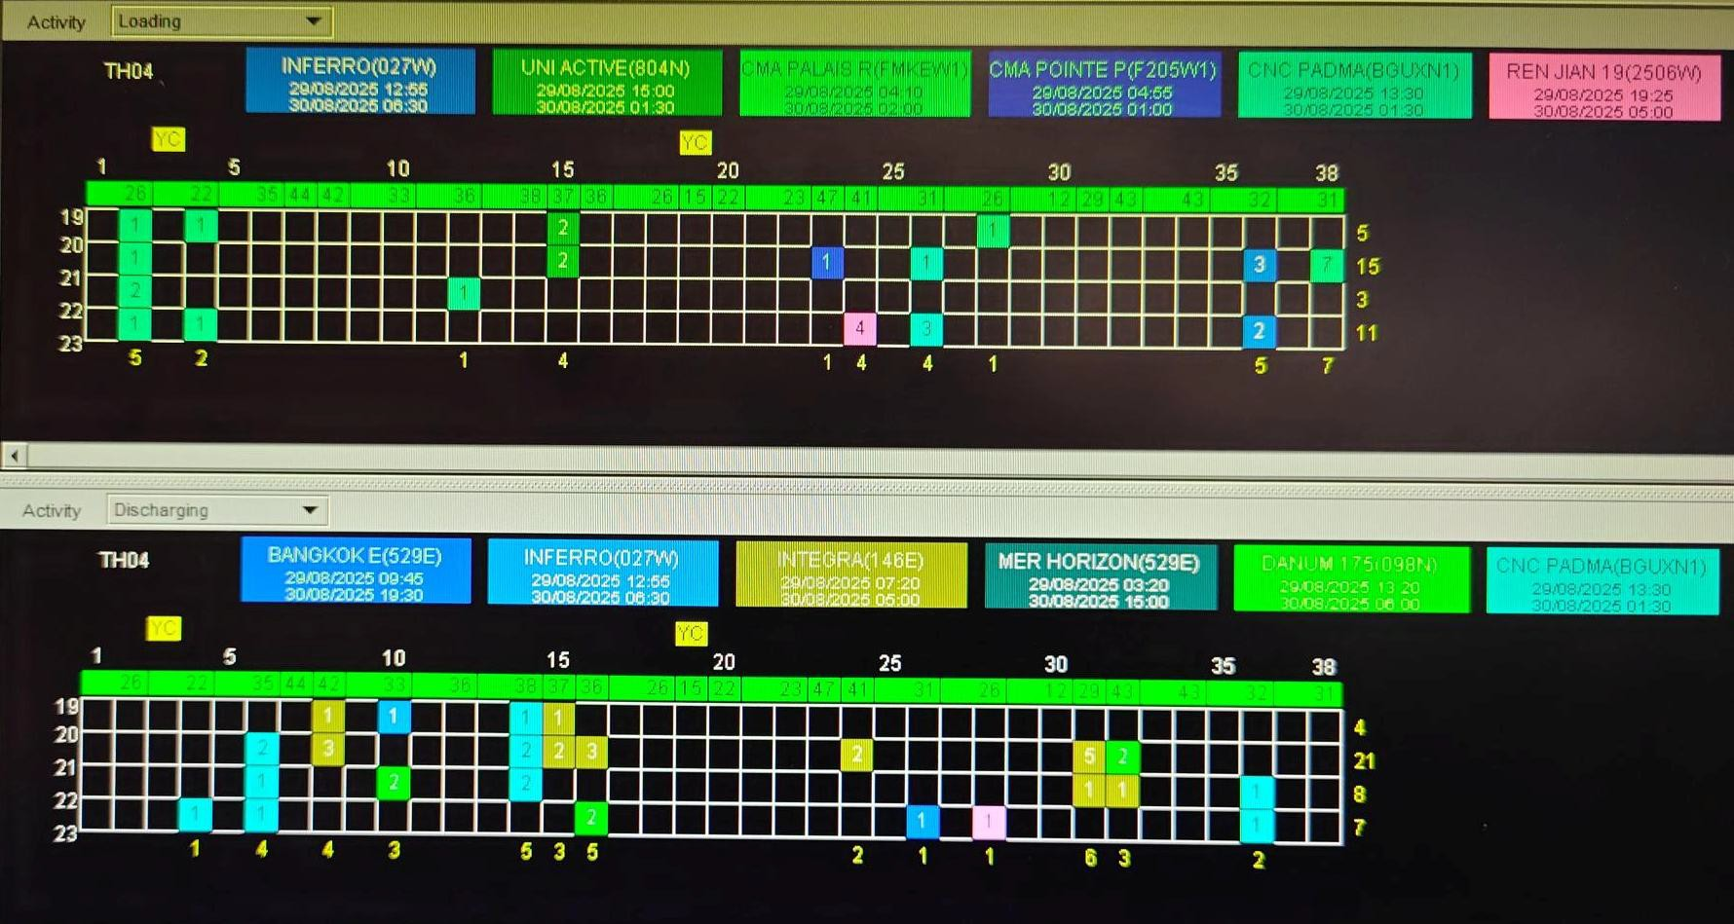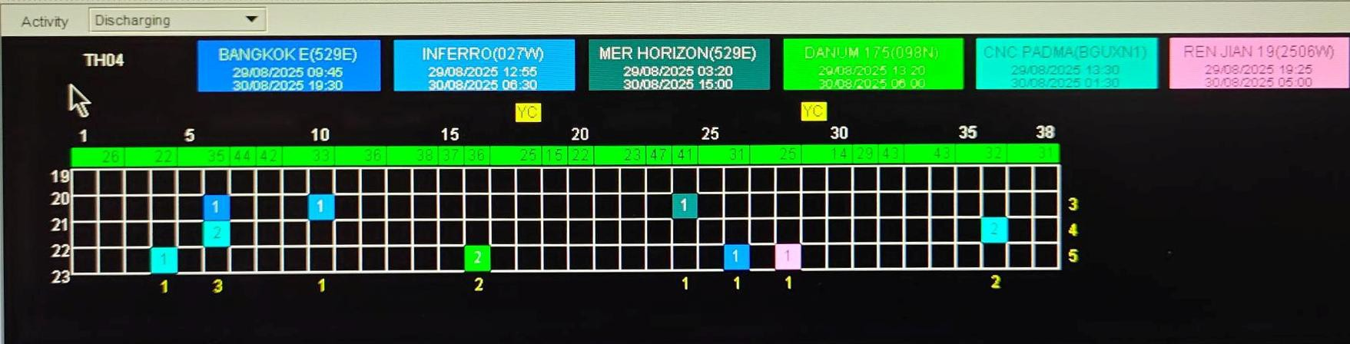

**Loading Activities**

**BEFORE**

**Discharging Activities**

**AFTER**

**Discharging Activities**

# : Vessel Operation Monitor and Control (YOMC)

* + 1. **: YOMC Panel**

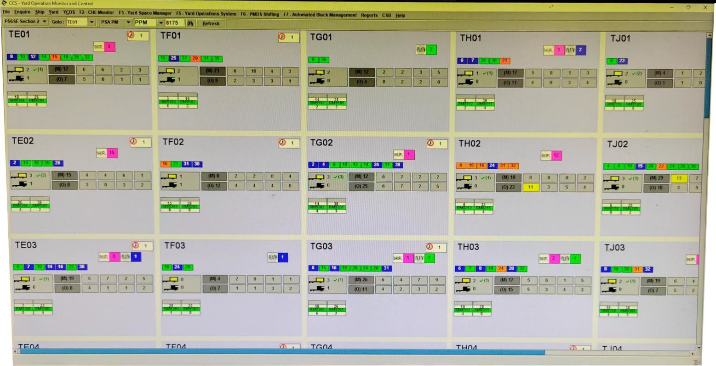

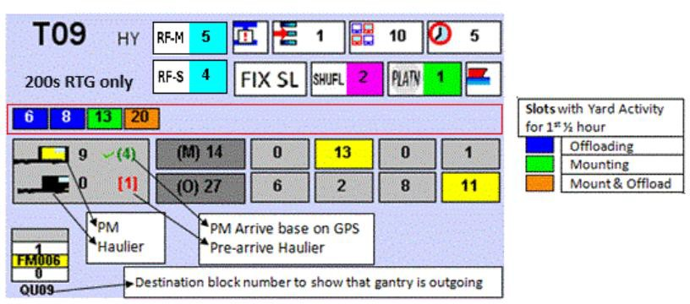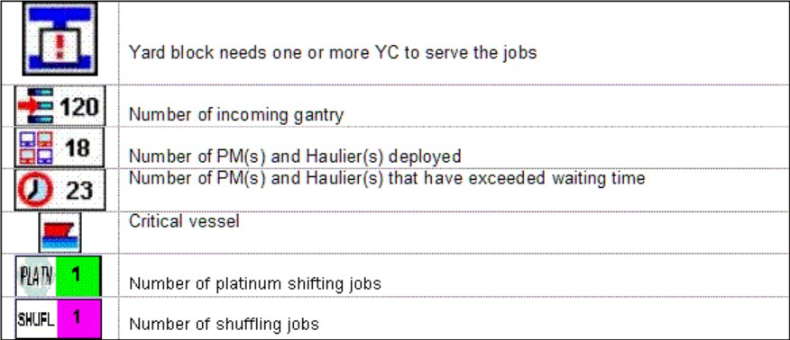

# : Automated Block Details

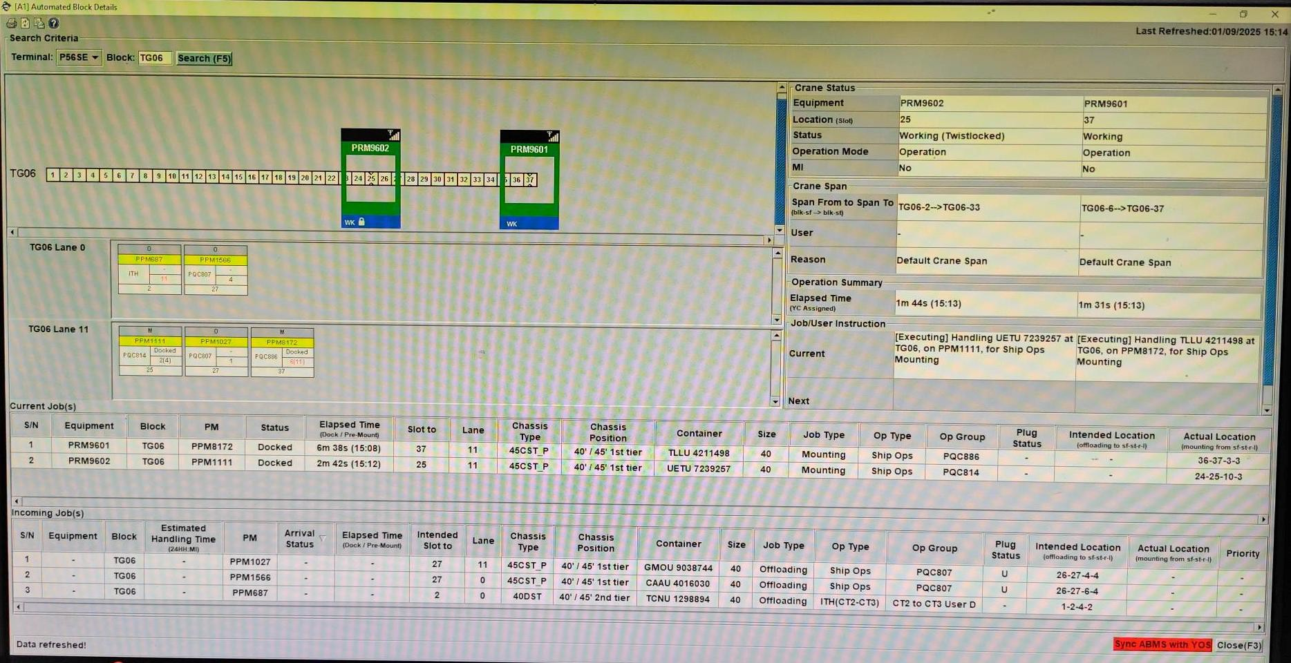

# : PM Monitor

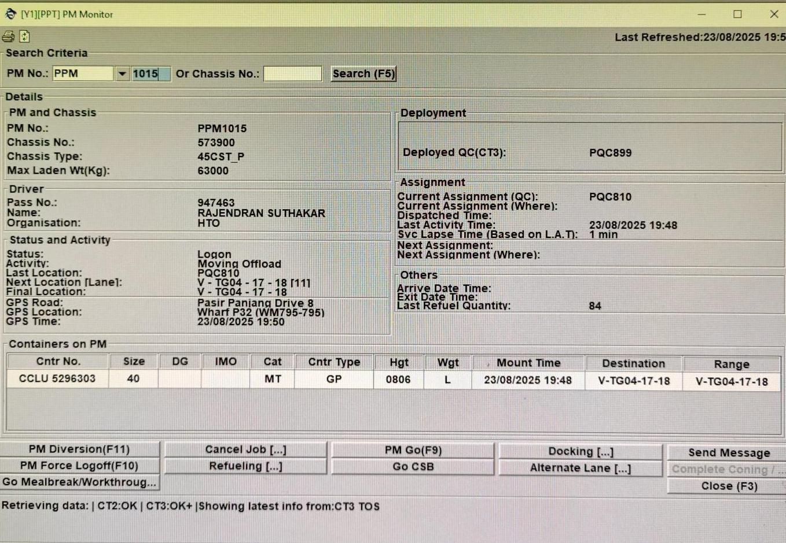

PM Diversion PM Force Logoff

* Opening Diversion Panel
* Logging off PM PC

GO Mealbreak / Workthrough – Select PM for Mealbreak / Work through

Searching PM information by PM or Chassis Number

Deploy where

Current Job Location

Job Duration

Container mounted on PM chassis

Cancel Job – Delete current job

PM Go – PM GO required after updated job manually

Key Arrived for PM

Message Driver

Refuelling – Next Job going for refuelling GO CSB – Next Job going for CSB

Changing for ARMG block: Lane 0 or Lane 11

# : No Show Report

Monitor no show closely to identify high waiting PM. Below is the example page of a no-show report.

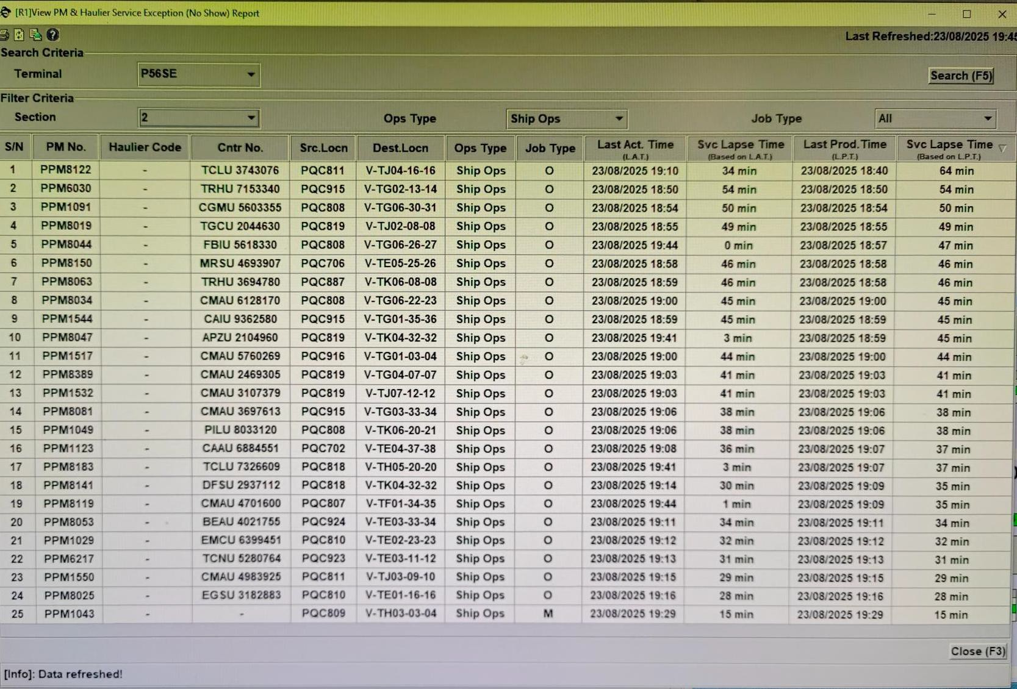

# : PM Unavailable / Deployed / Standby

Monitor PM Unavailable / Deployed / Standby closely to identify no yard allocation, PM should be diverted as soon as possible to prevent PM for incurring high waiting time. Below is the example page of a PM unavailable / deployed / standby.

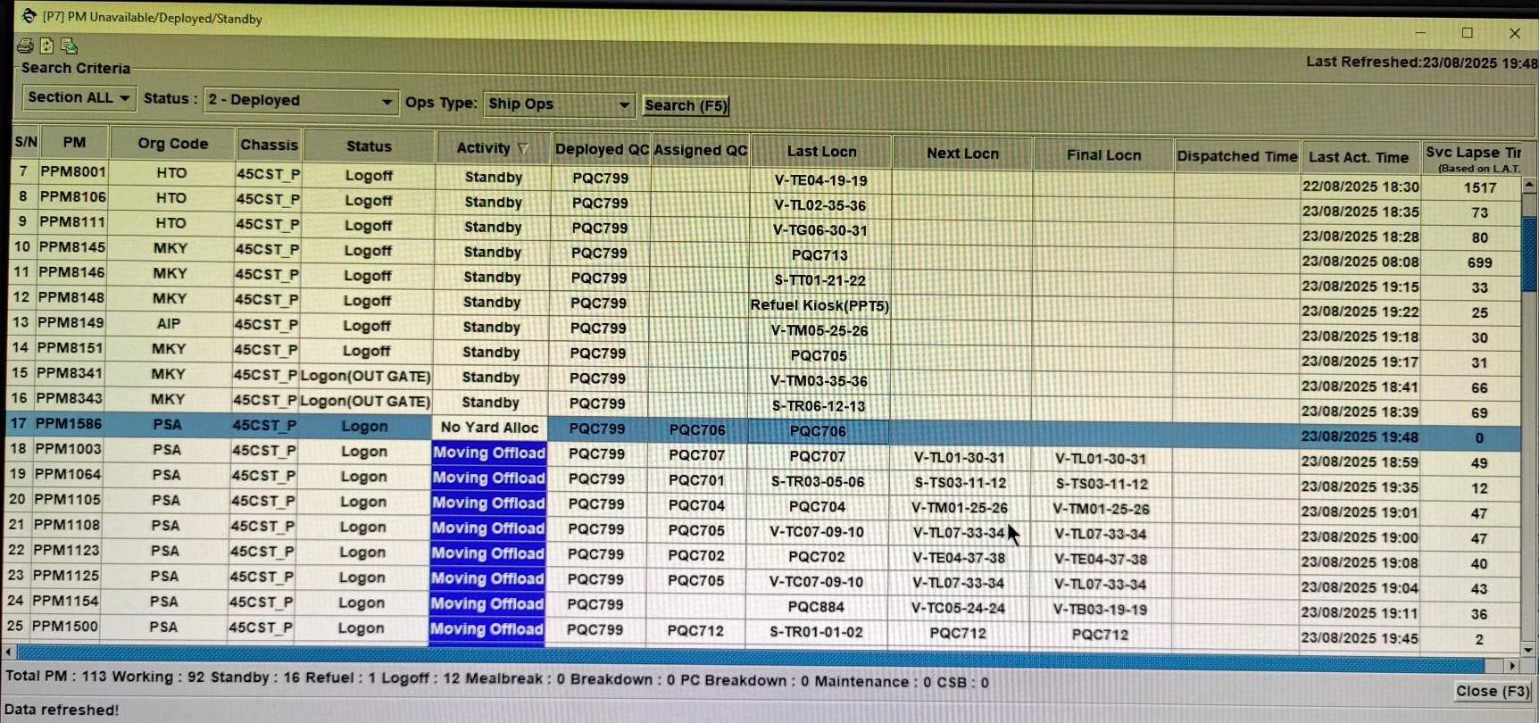

* 1. **: Common Alert & Notification System (CANS)**

**No Shuffling Location for Topmost Example:**

TP05 Slot 23 Row 9, within slot no place to shuffle to other row **Solution:**

Require raising side shuffling job or shift out over stow container with prime mover

**Max Stack Height Example:**

TG02 Slot 38 Row 8, slot full

**Solution:**

Require changing offloading location for prime mover

* + 1. **: CANS Panel**

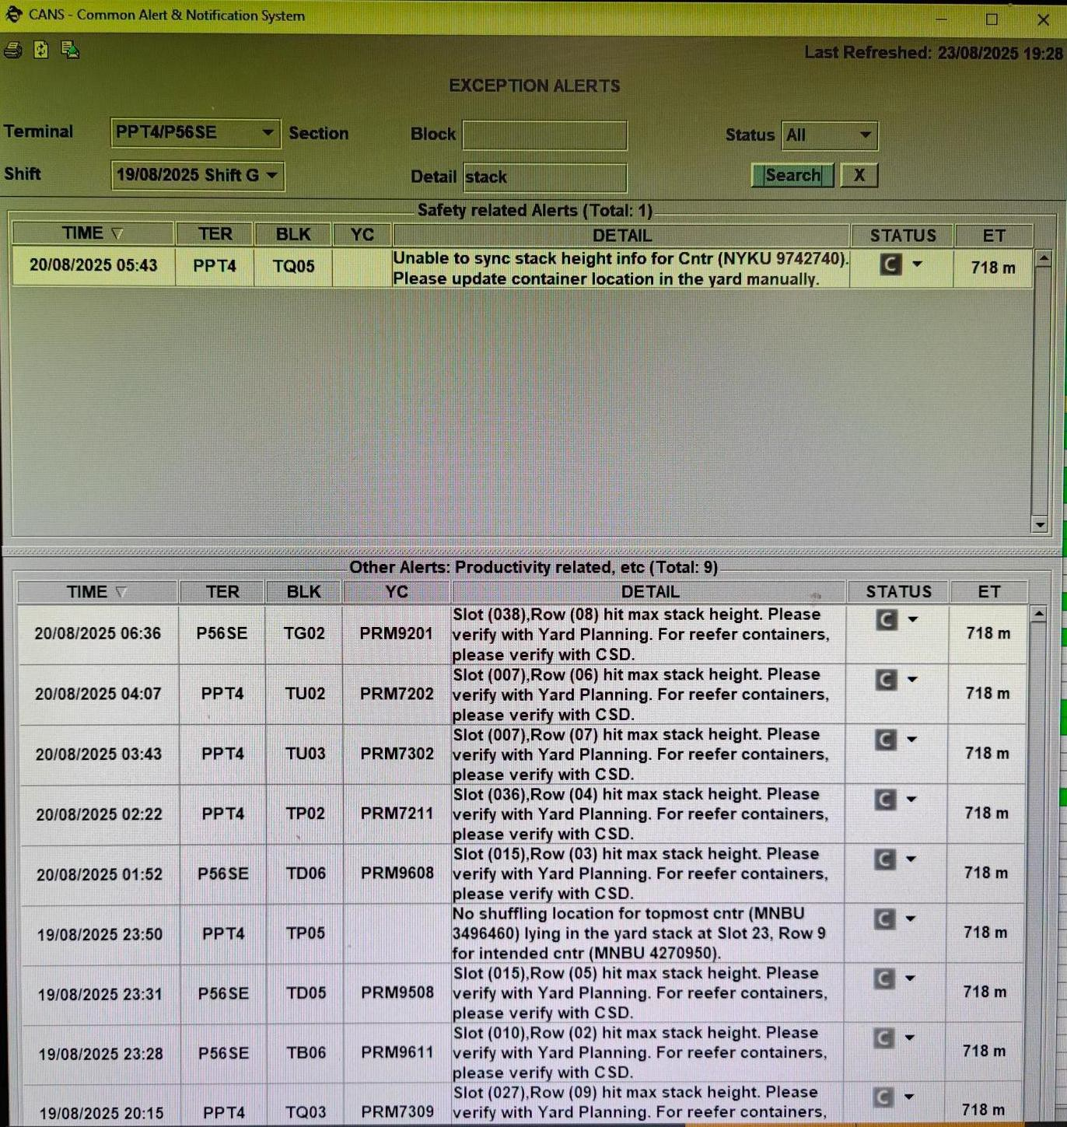

* 1. **: Vessel Operation Monitor and Control (VOMC)**
     1. **: Vessel Sequence (VOMC Panel)**

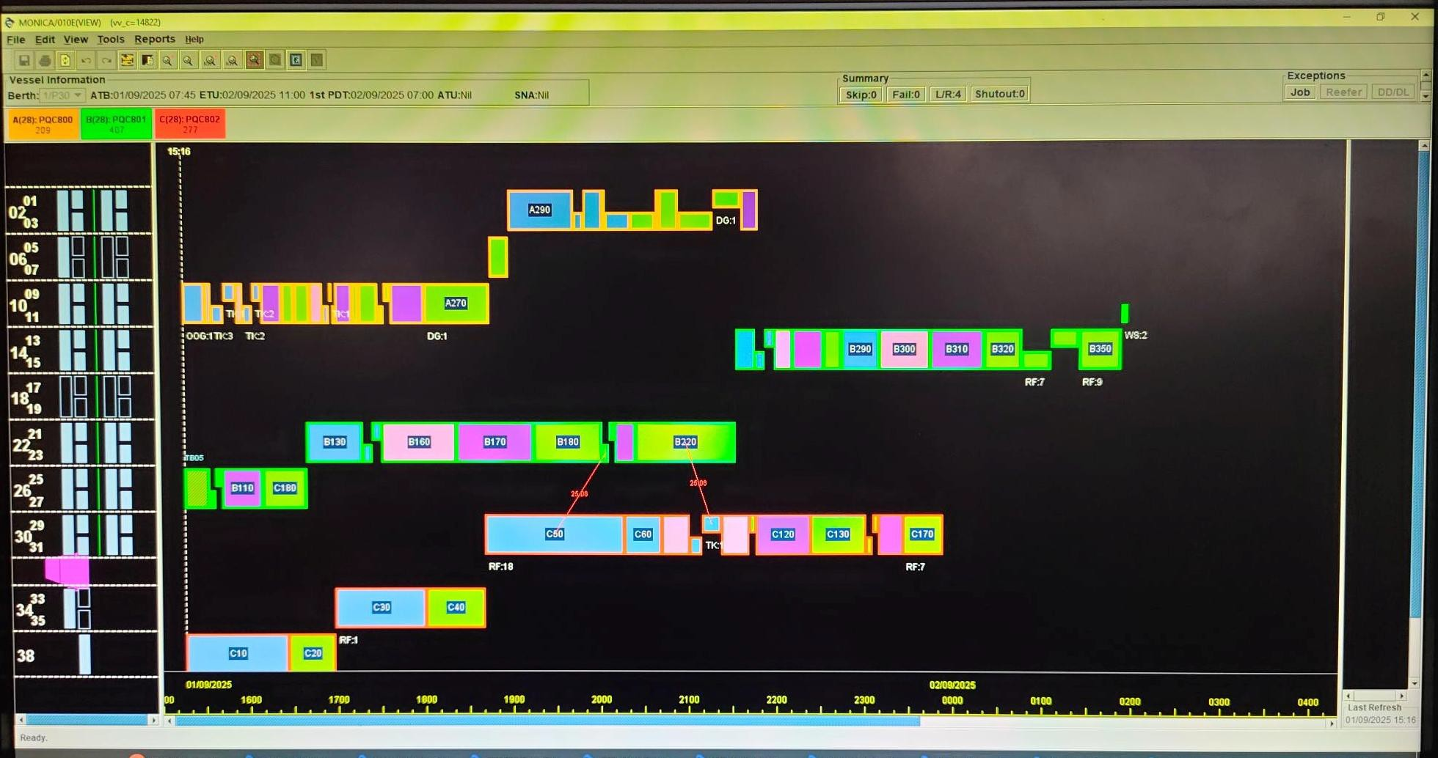

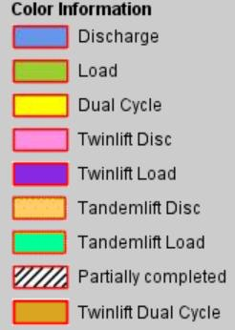

**Task 5: Gantry of RTGs and Yard Safety SOPs**

* 1. **: RTGs Block Channel**

|  |  |
| --- | --- |
| **RTG Block Channels** | |
| **Terminal P4** | |
| **Folder** | **Channel** |
| PPYD OTHERS | TR / 4-5 |
| TS / 4-5 |
| PPYD TP-TU | TT / 4-5 |
|  | |
| **Terminal P5** | |
| PPYD OTHERS | TL / 6 |
| TM-TN / 6-8 |
|  | |
| **Terminal P6** | |
| PPYD OTHERS | TH / 6-8 |

* 1. **: Road CCTV Camera Numbers for Gantry**

|  |  |  |  |  |  |  |  |
| --- | --- | --- | --- | --- | --- | --- | --- |
| **RTG Gantry CCTV Camera Numbers** | | | | | | | |
| **Terminal P4** | |  | **Terminal P5** | |  | **Terminal P6** | |
| **Junction** | **Camera Numbers** | **Junction** | **Camera Numbers** | **Junction** | **Camera Numbers** |
| TR / TS | TR6-T15L | TL / TM | TL3-T33S | TG / TH | TJ7-T46L TJ7-T46S |
| TR2-T23S | TL7- T43L TL7-T43S |  | |
| TS / TT | TS6-T14L | TM / TN  (Cannot Cross Gantry) | TM3-T32S |
| TS2-T22S | M8-T42L TM8-T42S |
|  | | TB / TN | TB3-T62S |
| TN8-T41L TN8-T41S |

* 1. **: Gantry RTG**
     1. **: Linear Gantry**
        + Immediately call RTG operator to “STOP” gantry, if observe any safety infringement and escalate to aYDM

|  |  |
| --- | --- |
| **Gantry Path CCTV Camera Views YOMC RTG Gantry Instruction** | A collage of images of two people  AI-generated content may be incorrect. (Rectangle) |
| A computer screen with text and images  AI-generated content may be incorrect. (Rectangle) | A collage of images of two people  AI-generated content may be incorrect. (Rectangle) |

|  |  |
| --- | --- |
| **RTG Block Channel RTG at RED/WHITE LINE** | A collage of images of a warehouse  AI-generated content may be incorrect. (Rectangle) |
| A close up of a radio  AI-generated content may be incorrect. (Rectangle) | A collage of images of a warehouse  AI-generated content may be incorrect. (Rectangle) |

* Tune to the gantry path CCTV camera views
* Send RTG gantry instruction via YOMC
* RTG operator check for obstruction on the gantry path, gantry to the last 40-footer slot (or 1st 40 footer slot) of the block and stop.
* Switch UHF set to RTG block channel (wait for RTG operator to call RP).
* RP Supervisor check for clearance, inform RTG operator to “Inch” out to

the RED/WHITE line and STOP.

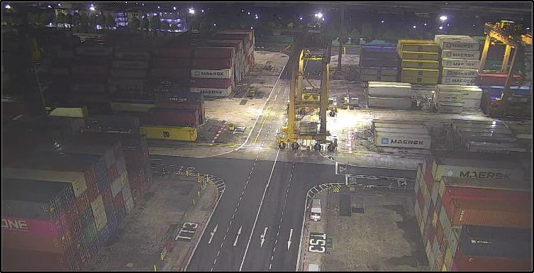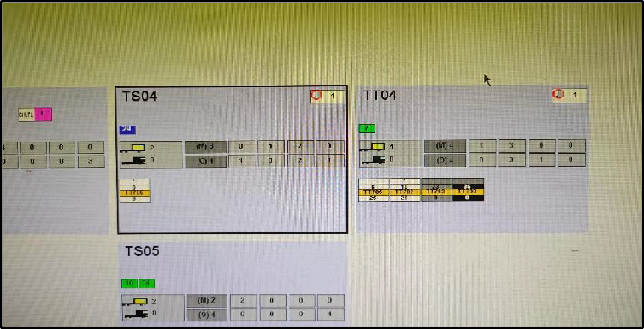

* RP Supervisor check for clearance on the street to the intended block (ensure that vehicles awaiting RTG gantry had hazard lights on before instructing RTG to gantry out of the block).
* Once cleared, inform RTG operator to activate the Siren and gantry on the street to the intended block.
* Once inside the intended block, key “arrived”, switch UHF to the block

channel and continue with operations in the block.

# : Cross Gantry

* + - * Immediately call RTG operator to “STOP” gantry, if observe any safety infringement and escalate to aYDM

|  |  |
| --- | --- |
| **Gantry Path CCTV Camera Views YOMC RTG Gantry Instruction** | A collage of a plane and a runway  AI-generated content may be incorrect. (Rectangle) |
| A screenshot of a computer  AI-generated content may be incorrect. (Rectangle) | A collage of a plane and a runway  AI-generated content may be incorrect. (Rectangle) |

|  |  |
| --- | --- |
| **RTG Block Channel RTG at RED/WHITE LINE** | A collage of a road  AI-generated content may be incorrect. (Rectangle) |
| A close up of a device  AI-generated content may be incorrect. (Rectangle) | A collage of a road  AI-generated content may be incorrect. (Rectangle) |

* Tune to the gantry path CCTV camera views
* Send RTG gantry instruction via YOMC
* RTG operator check for obstruction on the gantry path, gantry to the last 40-footer slot (or 1st 40 footer slot) of the block and stop.
* Switch UHF set to RTG block channel (wait for RTG operator to call RP).
* RP Supervisor check for clearance, inform RTG operator to “Inch” out to

the RED/WHITE line and STOP.

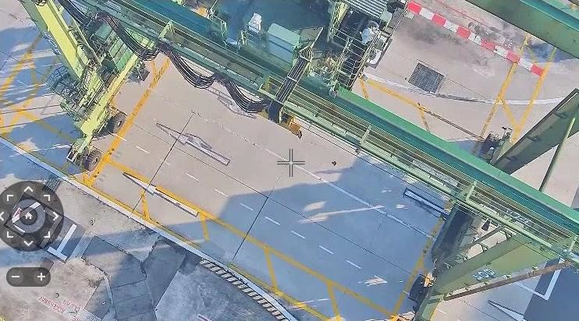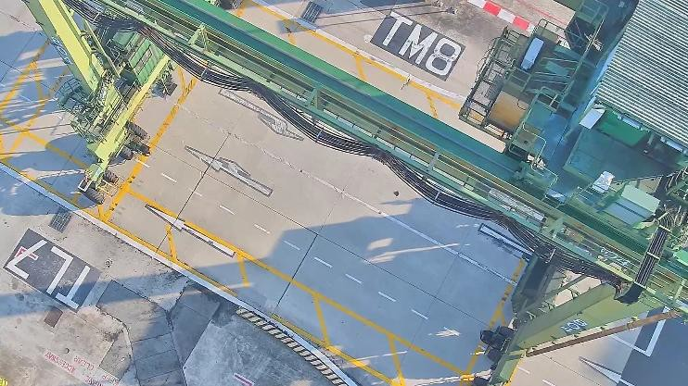

* RP Supervisor check for clearance on the street to the intended block (ensure that vehicles awaiting RTG gantry had hazard lights on before instructing RTG to gantry out of the block).
* Once cleared, inform RTG operator to activate the Siren and gantry out from the block to the designated spots on the Cross Gantry paths.
* When RTG operator stops at the correct cross-gantry path and inform RTG operator to proceed to do wheel turn.
* Once wheel turns completed, RP Supervisor checks for clearance to gantry on the street to the cross-gantry path outside the intended block.

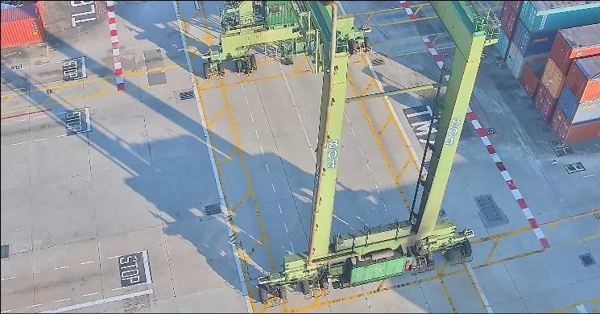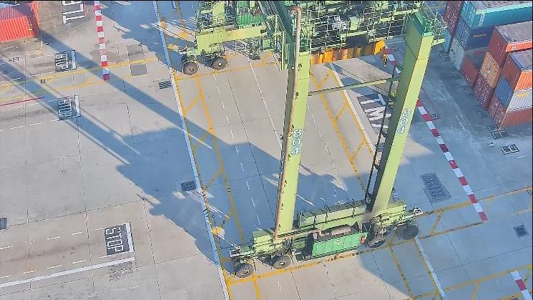

* Once cleared, inform RTG operator to activate the Siren and gantry toward the cross-gantry path outside the intended block.
* When RTG operator stops at the designated spots outside the intended block and inform RTG operator to proceed to do wheel turn.
* Once wheel turns completed, RP Supervisor checks for clearance to gantry into the intended block.

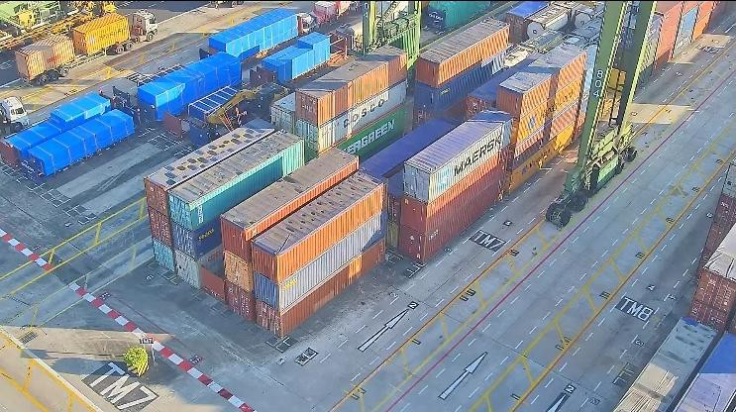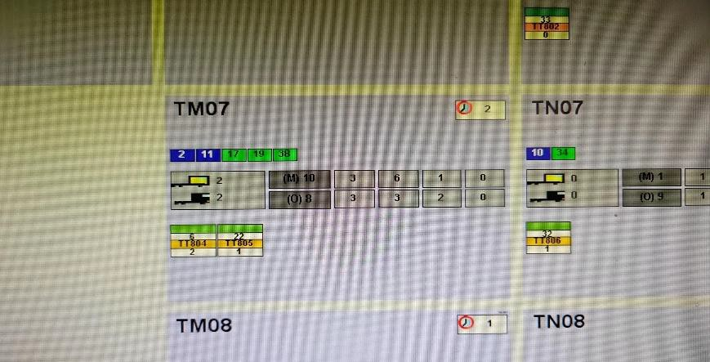

* Once cleared, inform RTG operator to activate the Siren and gantry into the intended block.
* Once inside the intended block, key “arrived”, switch UHF to the block

channel and continue with operations in the block.

# : Safety Concern

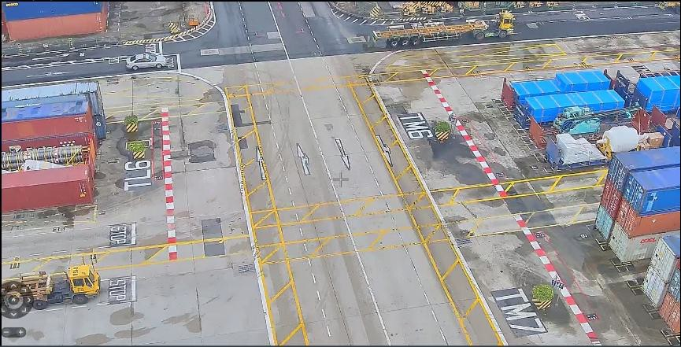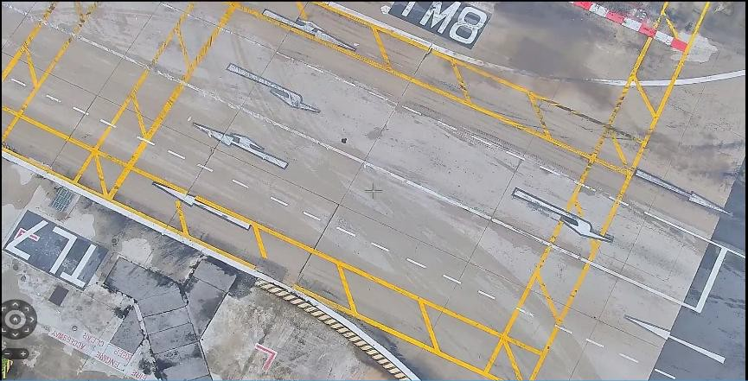

TL06 Designated Cross Gantry Path

TM08 Kerb Located Near Cross Gantry Path

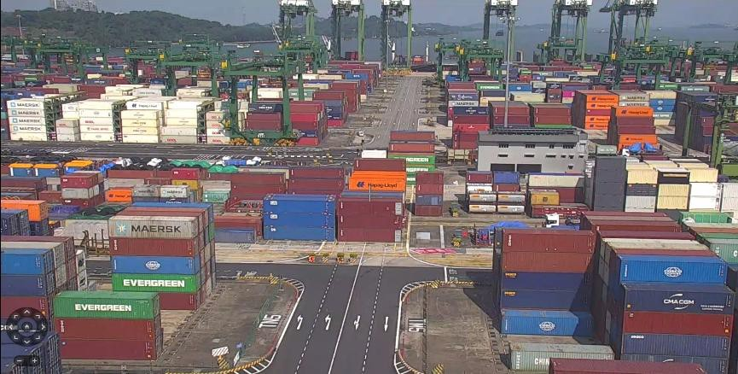

TN / TM Cannot Cross Gantry

# Task 6: Monitor Yard Operations

To optimize yard waiting time (the time where prime mover spends waiting in a yard during loading / discharging), several parameters can be considered.

1. By regularly monitoring no show report closely to identify high waiting PM (PC call checking on driver location)

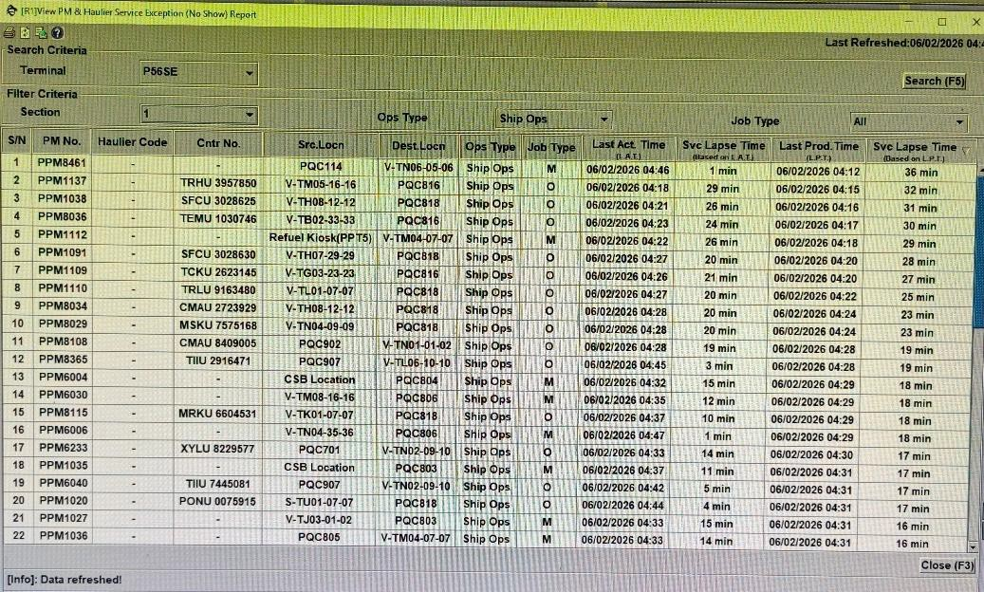

1. By regularly monitoring the yard location panel and promptly assigning yard location, offloading waiting time can be significantly reduced

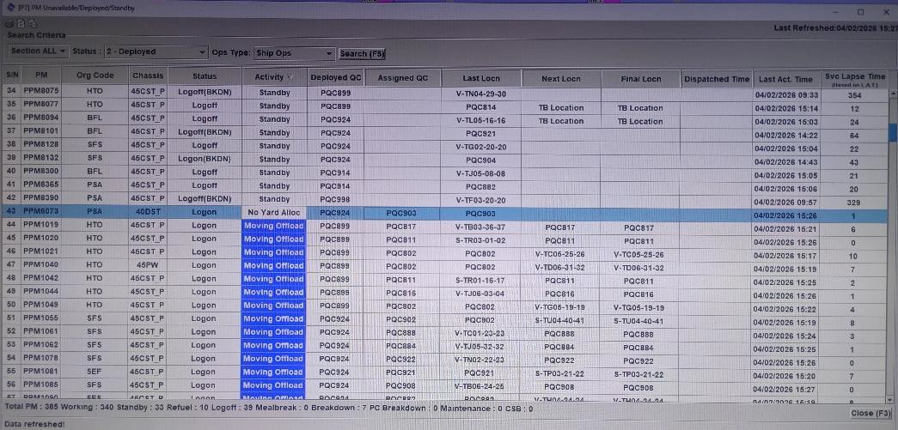

1. Immediately informing SOC possible to stagger or reduce PMs ratio if encounter heavy block mounting and working with AOC to put restricted region at the slot to focus on ship operation single point mounting job. Fully utilizing both ARMG lanes (lane 0 and lane 11) by changing PM lane if required.

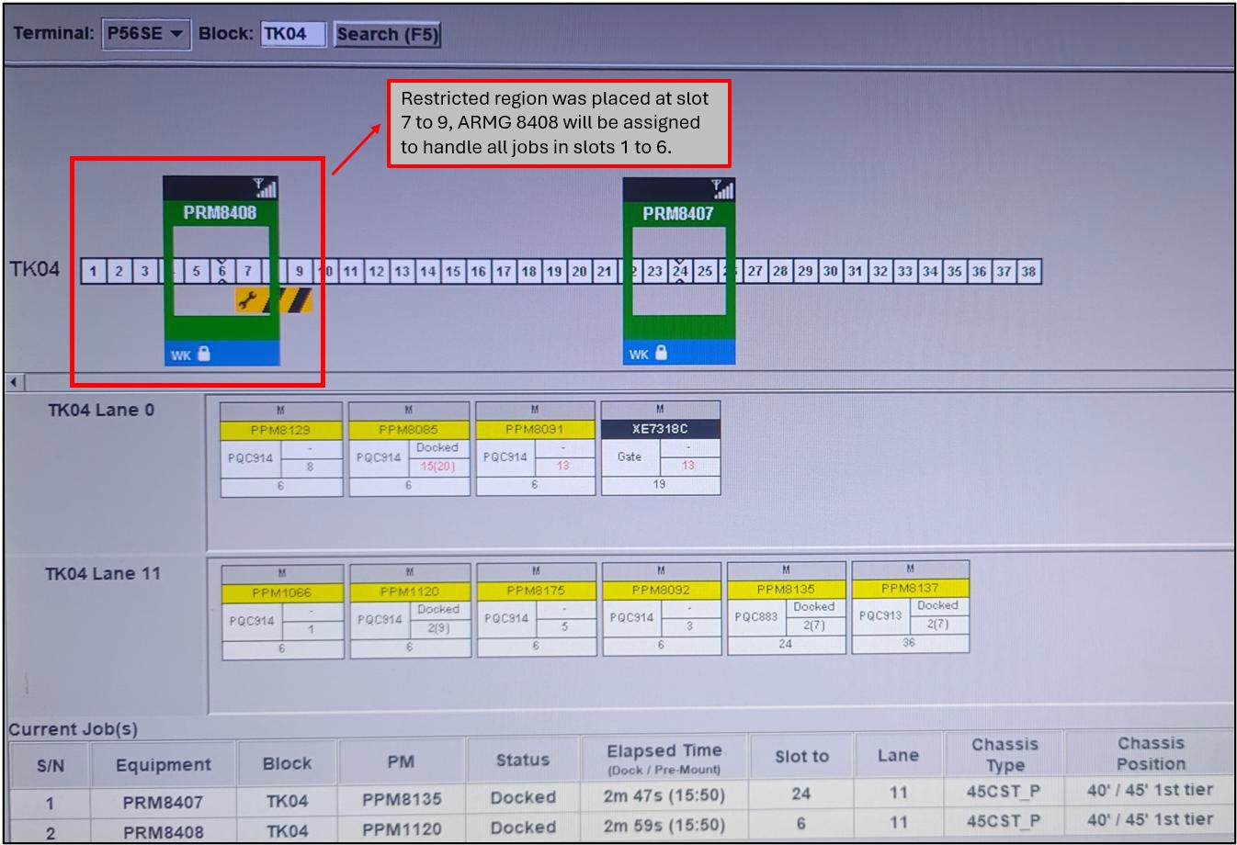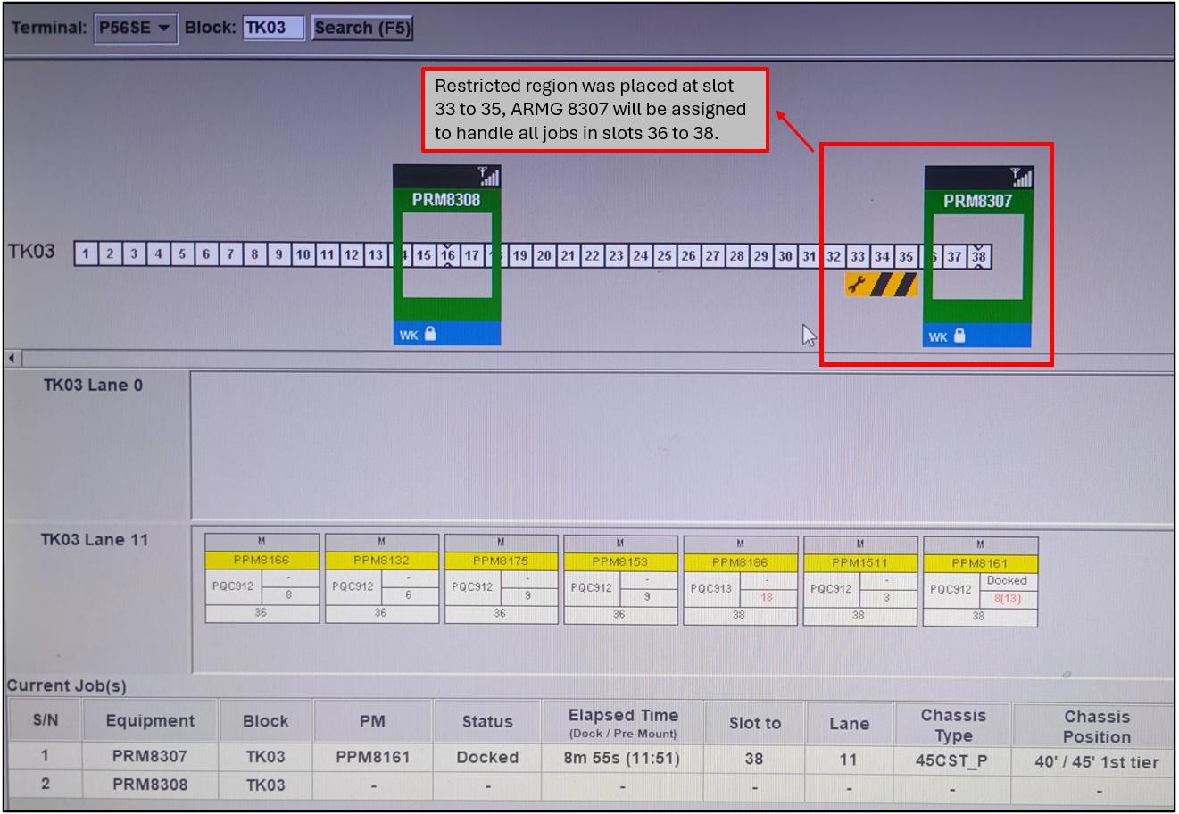

1. Forecasted single point mounting slot, raising CMRs for ARMG to side shuffling loading container to other slot, these may utilize both ARMG crane for mounting when the job is assigned.

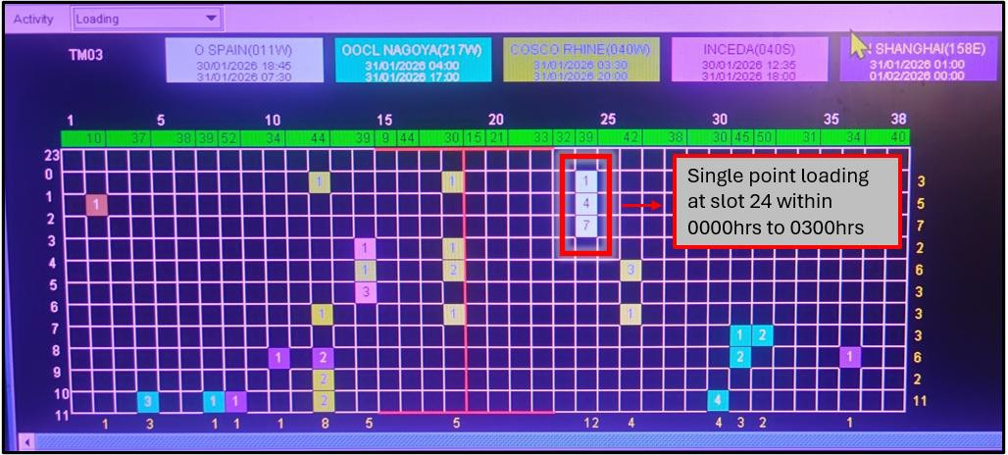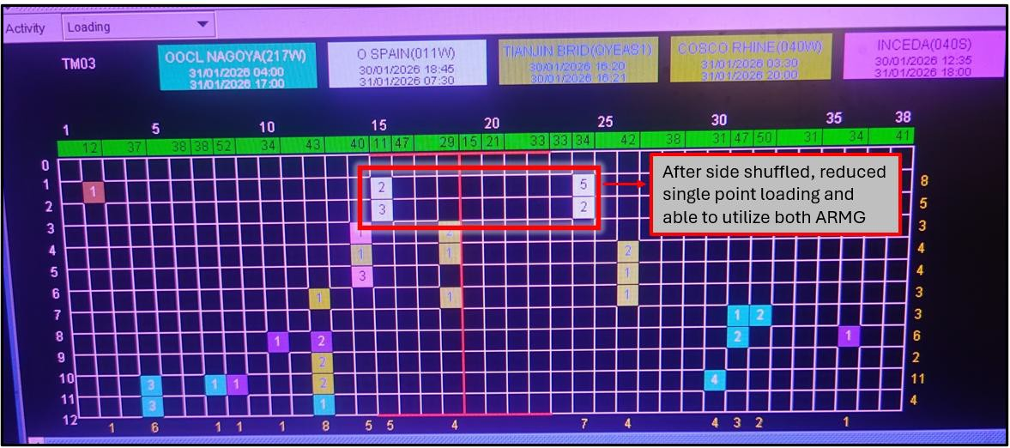

1. Regular replanning through Yard QCC and replanning single crane operation at the start of the shift.

# TL01: Single Crane Operation: Reduce Activities

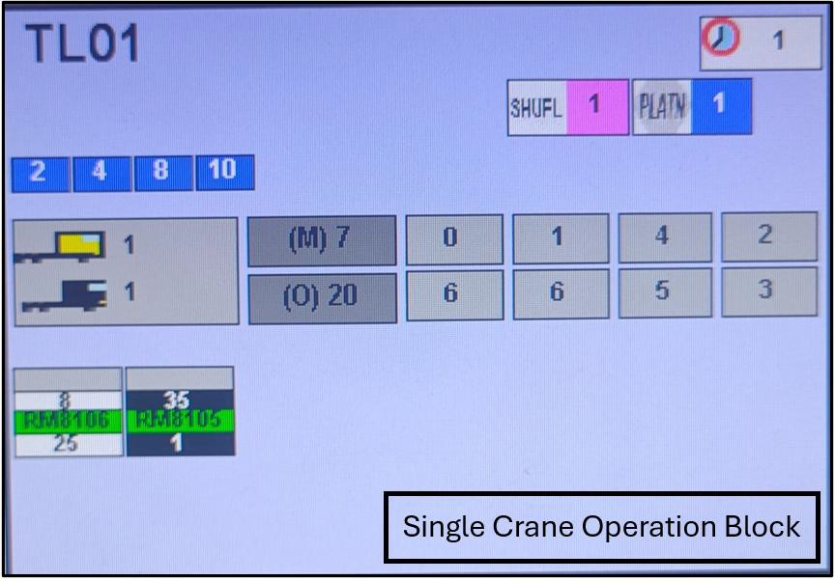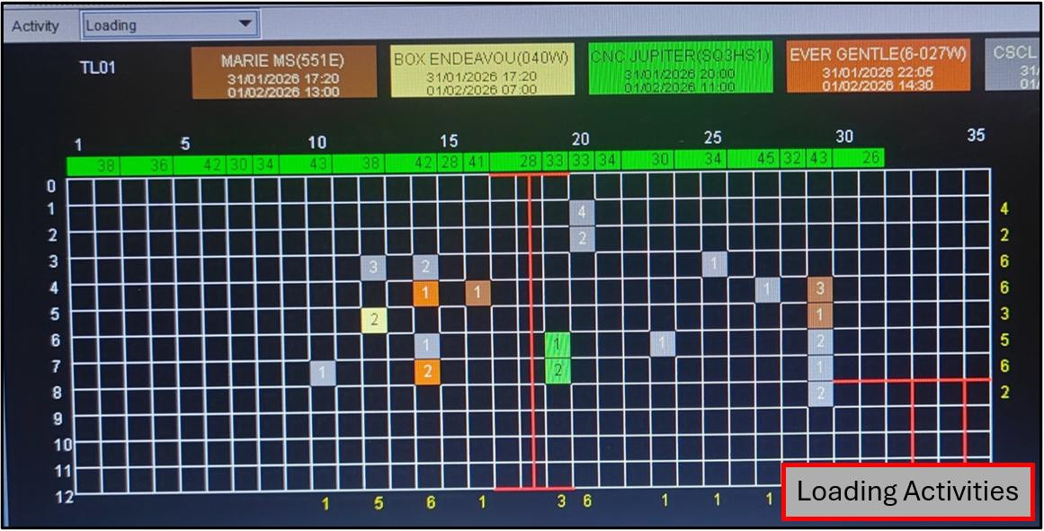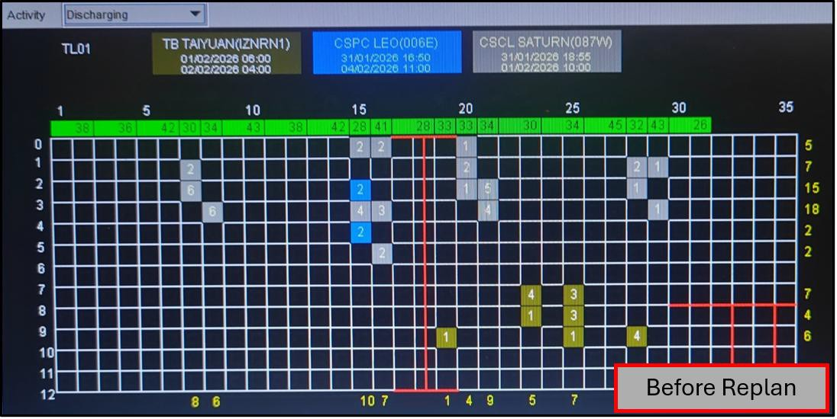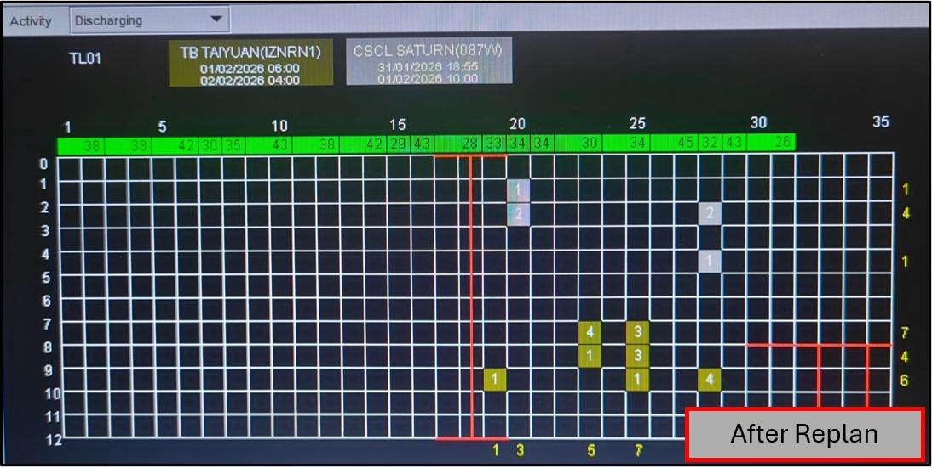

# TR03: Heavy Loading Activities: Reduce Activities

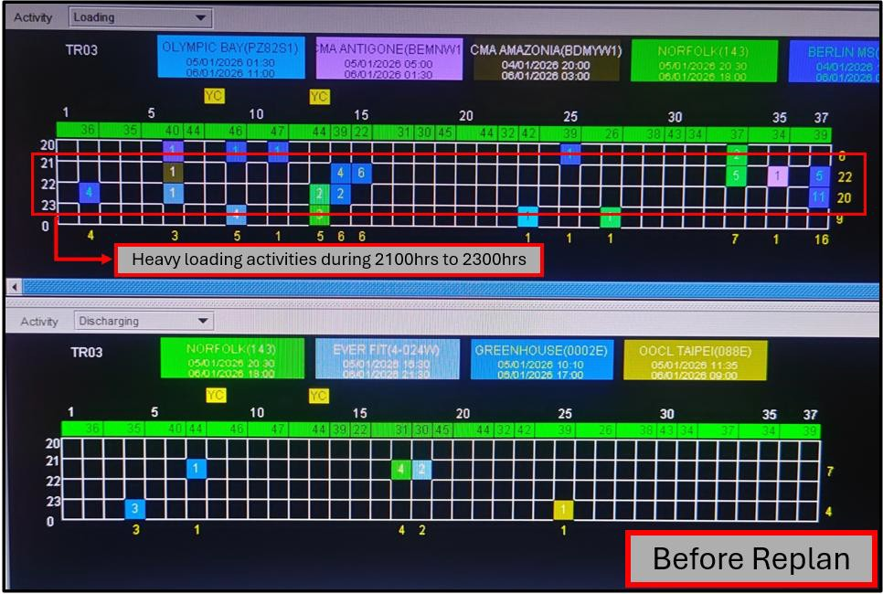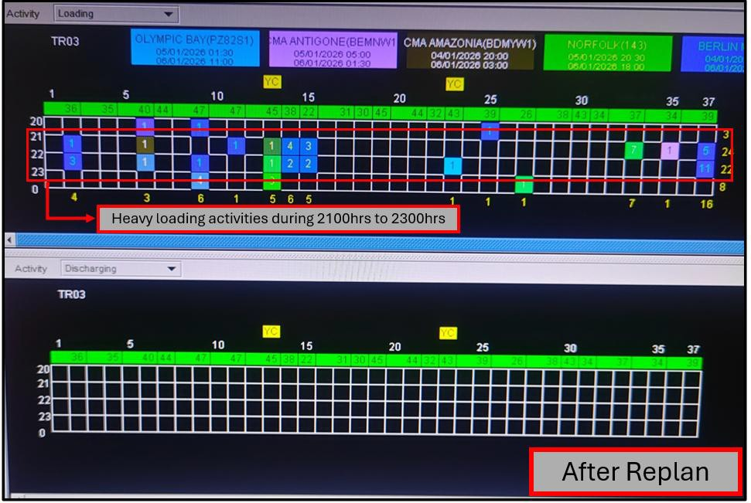

1. Fully utilize both Lane 0 and Lane 11 at the ARMG block to prevent congestion.

# TC02: Lane Management

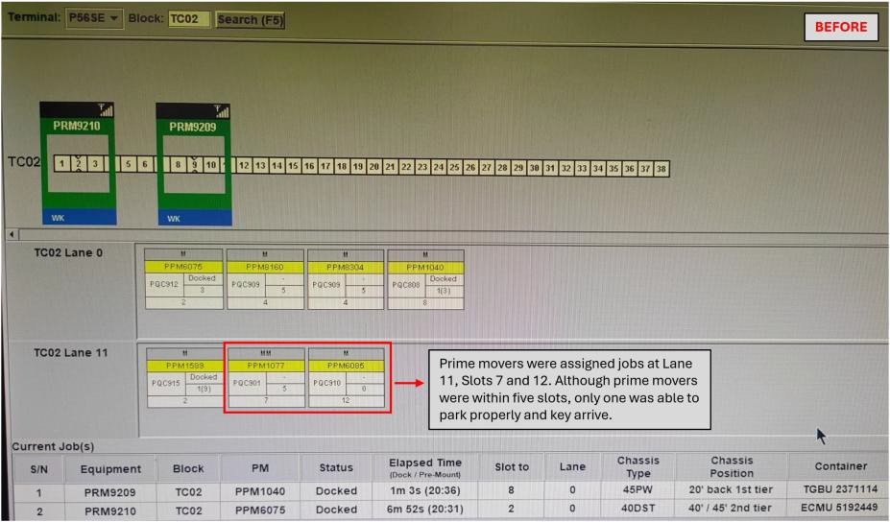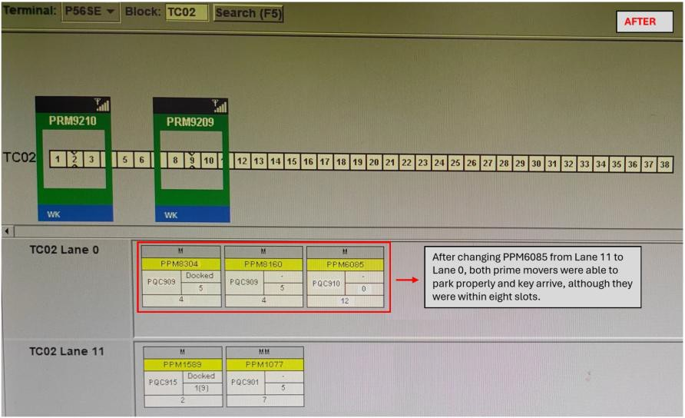

1. Haulier or prime mover reefer job remains plugged in, blocking the other prime mover from discharging the container.

**TN05: Lane Management or Informing Reefer Control to Divert Offloading Job**

|  |  |
| --- | --- |
|  | **BEFORE** |
|  | |

|  |  |
| --- | --- |
|  | **AFTER** |
|  | |

**Task 7: Forecast RTG Yard Activities and Equipment Positioning**

* 1. **: Forecast RTG Yard Activities Email by aYDM:**

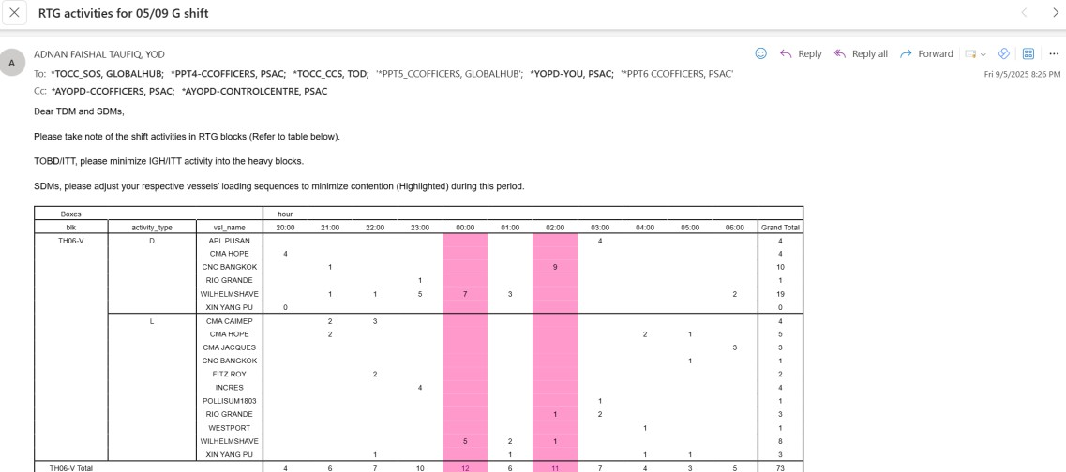

# Enhance Activities:

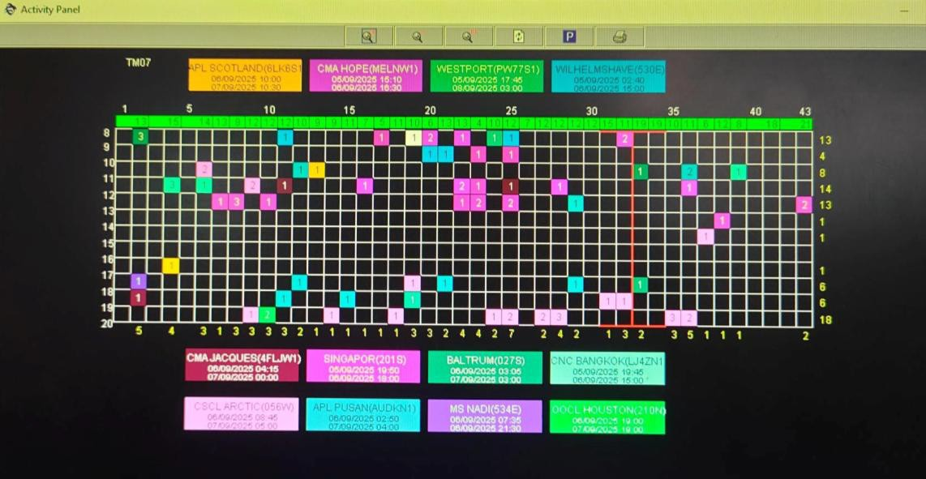

# : RTG Positioning

Reason for positioning RTG beforehand:

* + 1. Based on the RTG activities forecast through enhance activities or email sent out aYDM
    2. Based on operator skillset (experience operator for chain ops, DG, OH)
    3. Parking of RTG for servicing on the next day

# RTG Servicing Detail:

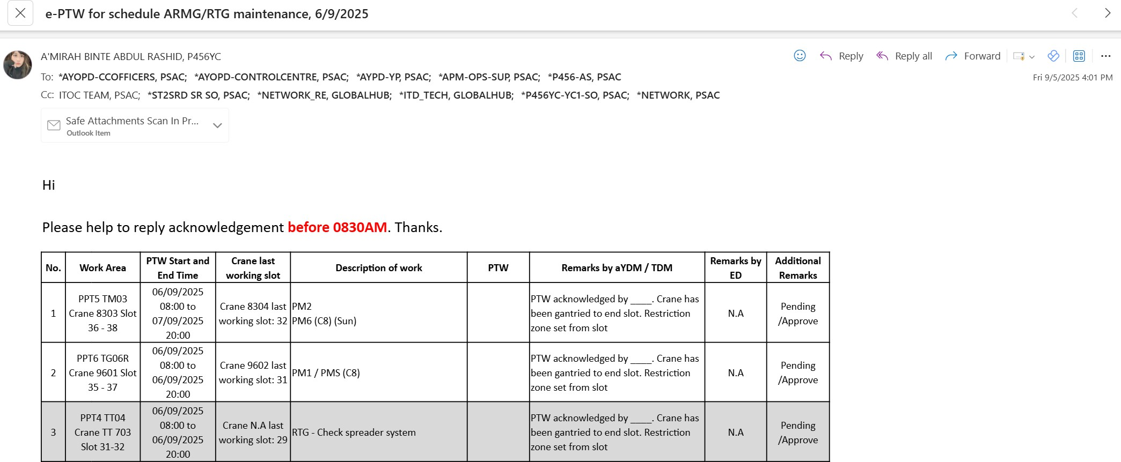

**Task 8: Diversion Basic Knowledge**

* 1. **: PSCW**
* **Port Mark**

Port Mark refers to designated discharging port of the vessel. Containers should not be stack if they are from different port mark within the same vessel.

# Size

Size refers to the length of the container. Do not mix 20ft, 40ft and 45ft.

# Category

Category refers to the type of container.

Do not mix different types of container type. GP, HC, FE, FR, TK, OH/OW/HW and DG.

# Weight

The lighter container should not be stacked on top of the heavier container. The weight indication for sea is in tonnage. **L**ight (3-9.9), **M**edium (10-14.9), **H**eavy (15-19.9), **X**tra (20-24.9) and **U**ltra Heavy (≥25) Below table shows the weight class of the container weighing from the heaviest to the lightest.

|  |  |  |
| --- | --- | --- |
| **U** | (Ultra Heavy) | **Heaviest** |
| **X** | (Extra Heavy) |  |
| **H** | (Heavy) |  |
| **M** | (Medium) |  |
| **L** | (Light) | **Lightest** |

# : Stacking Height

|  |  |
| --- | --- |
| **Types of Containers** | **Stacking Height** |
| GP, HC, MT, MH, MR, RH | 5 |
| TE, OT | 4 |
| *TK, DG, DM, FE | 2 |
| FR | 1 |

**\* TK** must be planned / diverted at RTG block inner row (row 2 to row 5)

# : Illustration of Containers in the Yard

|  |  |
| --- | --- |
| **Opening the block without selecting any vessel cluster** | **Opening the block by selecting the vessel cluster** |
|  |  |

**Understanding of the Indication:**

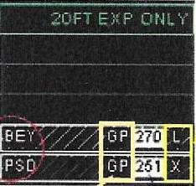

* Number indicates the duration stay of the container in the port
* The smaller the number, the earlier the ETB of the vessel

**Container Category**

**Weight Class**

**Port Mark**

|  |  |  |  |
| --- | --- | --- | --- |
| **Types of Containers** | **Description** | **Opening the block without selecting any vessel cluster** | **Opening the block by selecting the vessel cluster** |
| Landed Container | Container that lied / landed in the location. Can be identified by the strip lines. |  |  |
| Planned Container | Container that planned to move to the location. No stripe lines will be shown in the planned container. |  |  |
| Shut Container | Container that will not be loaded onto the vessel. May be due to change in the loading vessel. |  | |
| ATM Container | Container that has a long stay in the yard. There is neither a specific port mark nor the port stays of the container. |  | |

# : Shuffling Tools

* + 1. **: Shift by Range**

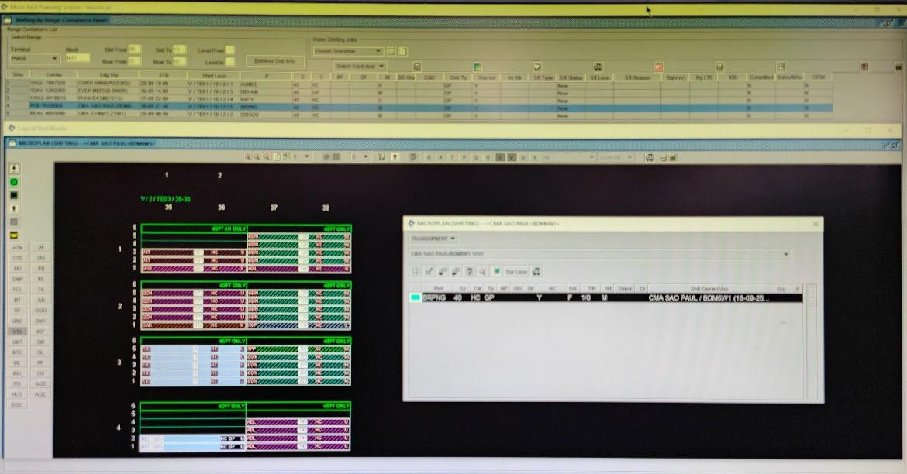

# : Shuffling Panel

Link to the shuffling panel: [https://web.ops.planning.psa/yard/profile-management/](https://apc01.safelinks.protection.outlook.com/?url=https%3A%2F%2Fweb.ops.planning.psa%2Fyard%2Fprofile-management%2F&data=05%7C02%7Clzhixuan%40globalpsa.com%7C9593815e522a4413214508ddc8bc67fb%7Cbc1b92b95dc949be995bc97eb515a1d3%7C0%7C0%7C638887433745269311%7CUnknown%7CTWFpbGZsb3d8eyJFbXB0eU1hcGkiOnRydWUsIlYiOiIwLjAuMDAwMCIsIlAiOiJXaW4zMiIsIkFOIjoiTWFpbCIsIldUIjoyfQ%3D%3D%7C0%7C%7C%7C&sdata=qlfc7ZGfjffuVPYWW94KEKQyuNGGmj%2FntGBB%2Bt5RBMA%3D&reserved=0)

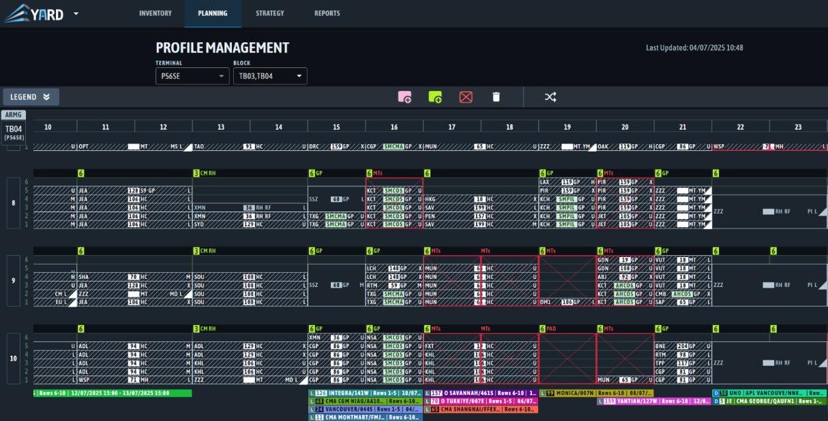

# : Dangerous Goods (DG)

Dangerous goods are solids, liquids, or gases that can harm people, other living organisms, property, or the environment. They require specialized methods of handling, transporting, storing, and disposing. They are often subject to both local and international regulations. Dangerous goods include materials that are radioactive, flammable, explosive, corrosive, oxidizing, asphyxiating, biohazardous, toxic, pathogenic, or allergenic.

# Classification of DG:

**PSA group:**

A classification by PSA Chemcare to further assess the extent of hazard within each DG so as to determine the appropriate handling and storage rules within PSA.

DG are identified, handled and stored according to the following classification criteria:

1. IMO Class: A number (1-9), designated by IMO to identify the hazard type of each DG.
2. UN Number: A 4-digit ID used to identify major chemicals as well as generic chemical groups.

**Location of DG:**

|  |  |  |  |
| --- | --- | --- | --- |
| **DG3 GP / HC Container:** | | **DG3 TK Container:** | |
| **IMO Class** | **ARMG Blocks** | **IMO Class:** | **RTG Blocks:** |
| IMO 3 | TL01 – TL05 | IMO 3 | TR04 |
| IMO 4.2 | TR01 – TR03 | IMO 8 | TS04 / TS05 |
| IMO 5.1 | TD01 – TD07 | IMO 2.2 / IMO6.1 / IMO 9 | Any RTG Blocks |
| IMO 8 | TS01 – TS03 | **\* TK containers – 2 High only and can be offload at row 2 to row 5 only** | |
| IMO 2.2 / IMO 6.1 / IMO 9 | Any ARMG Blocks |

|  |  |
| --- | --- |
| **DG1C / 2B / 2C / 2S GP / HC Container:** | |
| **IMO Class** | **Locations:** |
| IMO 2.1 / 2.2 / 2.3 | TH08 |
| IMO 3 | TH06 / TH07 |
| IMO 4.1 / 4.2 / 4.3 | TH06 / TH07 |
| IMO 5.1 | TN07 |
| IMO 5.2 | TH07 |
| IMO 6.1 | TL06 / TH06 / TH07 |
| IMO 7 | TH07 |
| IMO 8 | TL06 / TH06 / TH07 |
| IMO 9 **(DG2B)** | TN07 / TM08 |
| IMO 9 **(DG2C / 2S)** | Any ARMG Blocks |
| * TK containers – 2 High only and can be offload at row 2 to row 5 only | |
| * GP / HC containers – 3 High only | |
| * **20ft** GP / HC containers | Required to offload following by the door facing direction: (**Odd** Number Slot – Door facing **AFT**)  (**Even** Number Slot – Door facing **FWD**) |

|  |
| --- |
| **Important Stuffs to Take Notice:** |
| \***DG Group 2 / 1D Class** – Need to check with yard planner before offloading into yard, need to check the UN number. |
| \***IMO 1.3 / 1.4** – Unable to offload at CT3 yard, only able to offload at CT2 yard, required to inform SOC, if any. |
| \***IMO 5.1 (DG 1N)** – Unable to offload at CT3 yard, only able to offload at CT2 yard, required to inform SOC, if any. |
| **Overflow / Ad-hoc DG location** – Required to check email sent out by yard planner before using the ad-hoc space. |

**Task 9: Yard Exceptions**

* 1. **: Handle and Escalate Different Yard Exceptions**

This task helps you to identify, handle, and escalate various yard exceptions to maintain operational continuity and safety. You will learn protocols for common exceptions like misplaced containers, equipment failures, and hazardous situations.

# Learning Objectives:

* + - Recognize different types of yard exceptions
    - Execute proper handling procedures
    - Apply escalation protocols
    - Document exceptions accurately
    - Coordinate with relevant teams

**Common Yard Exceptions & Handling Procedures**

|  |  |  |  |
| --- | --- | --- | --- |
| **Exception Type** | **Escalation Protocols** | **Action To Be Taken** | **Others** |
| Missing Container | aYDM | * YDM will engage the AOCs to tally physical containers with PC location * aYDM to ENQC last known location * aYDM will escalate to respective terminals | To update correct location once container has been found |
| PM Breakdown | SRDO PMOC aYDM | * PM driver requires to notify SRDO * YSS requires to check on status with SRDO after 15min of non-recovery * If PM is unable to recover, check with PMOC for alternative equipment for drivers to take over * Notify aYDM if driver is put on standby due to insufficient equipment | To be updated in YSS report |
| PM reported container on chassis leaking | aYDM YPDM | * Inform shift aYDM of exception with container number, PM number and location * Inform YPDM of exception | Ensure container is updated  Location to be given by YPDM and aYDM need to follow up with respective terminal |
| PM not deployed following shift | Nil | * Ensure PM is released 30-35min before shift ends * Ensure PM is on empty chassis | - |
| PM missing and uncontactable | Shift aYDM PMOC | * Inform shift aYDM & PMOC, provide info such as PM number, time uncontactable, duration uncontactable, last seen GPS location | Close loop once driver has been found aYDM requires to follow up with PMRD if needed |
| System/PC related issues | Shift aYDM | * Inform shift aYDM * Take screenshots of issue (if any) * Explain problem statement | Close loop once problem has been resolved |

**Scenario Based Questions:**

**1: Single Crane Block**

**Based on the block TB04 on the left, what should a replanner do?**

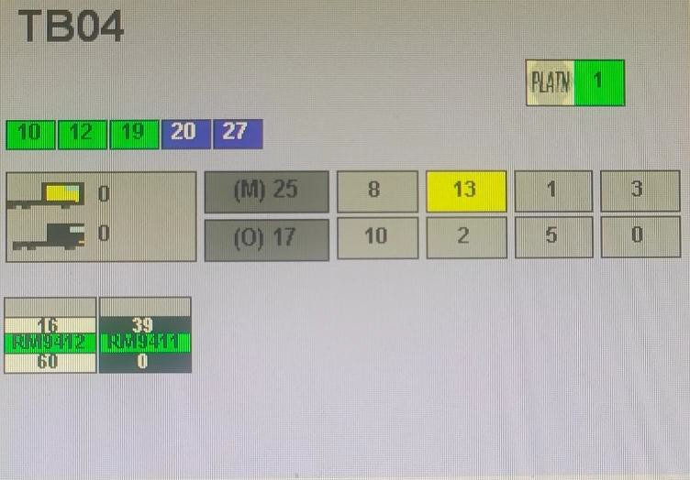

# 2: Prime Mover with High Waiting Time

**PPM8411 was assigned a mounting job at TD06, slot 8. After 25 minutes, the driver had not arrived at the location. What should a replanner do?**

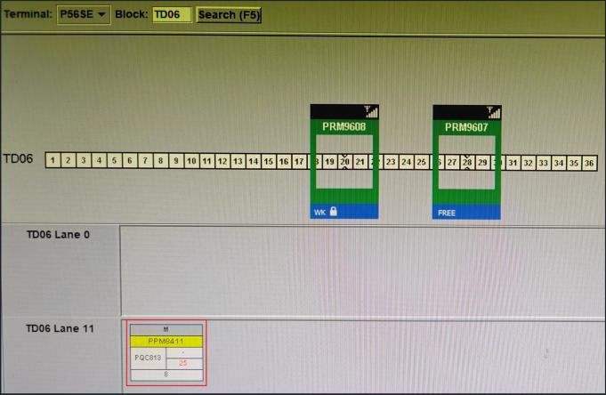

# 3: ARMG Block Heavy Mounting Activities

**Based on the block TM04 on the left, what should a replanner do?**

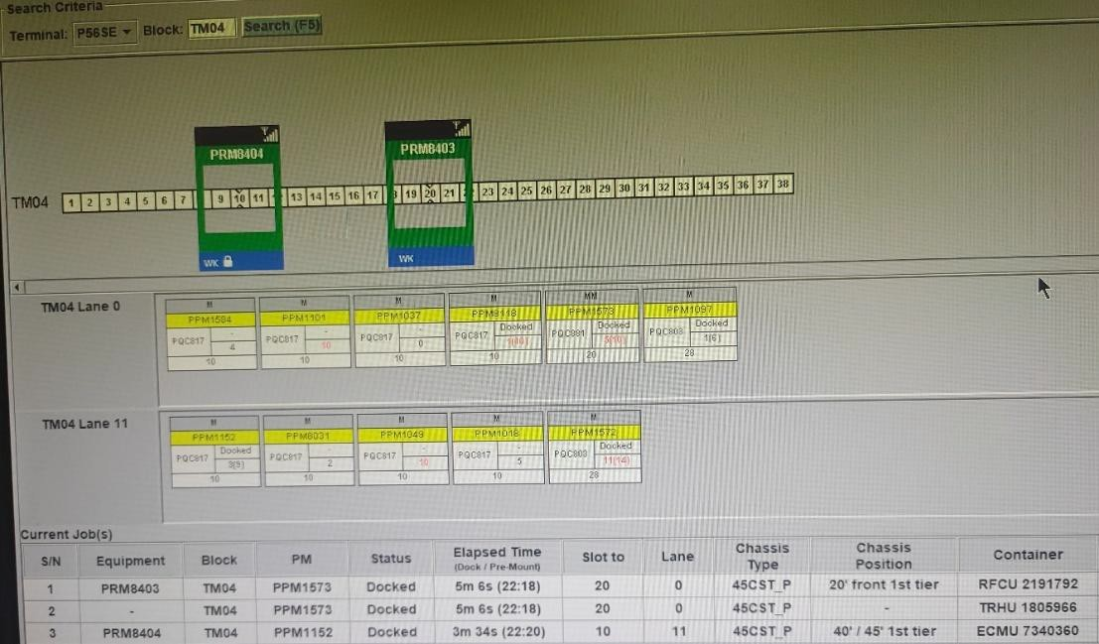

1. Informing AOC to place restricted region at slot 12 to 14, allowing ARMG 8404 to focus on smaller slot mounting job (slot 10).
2. Any incoming offload job, manually diverting out of the block
3. Changing prime mover lane (lane management), utilize both lane (lane 0 and lane 11)
4. All the above

# 4: RTG Block Heavy Mounting Activities

**Based on the RTG block TL06 on the left, what should a replanner do?**

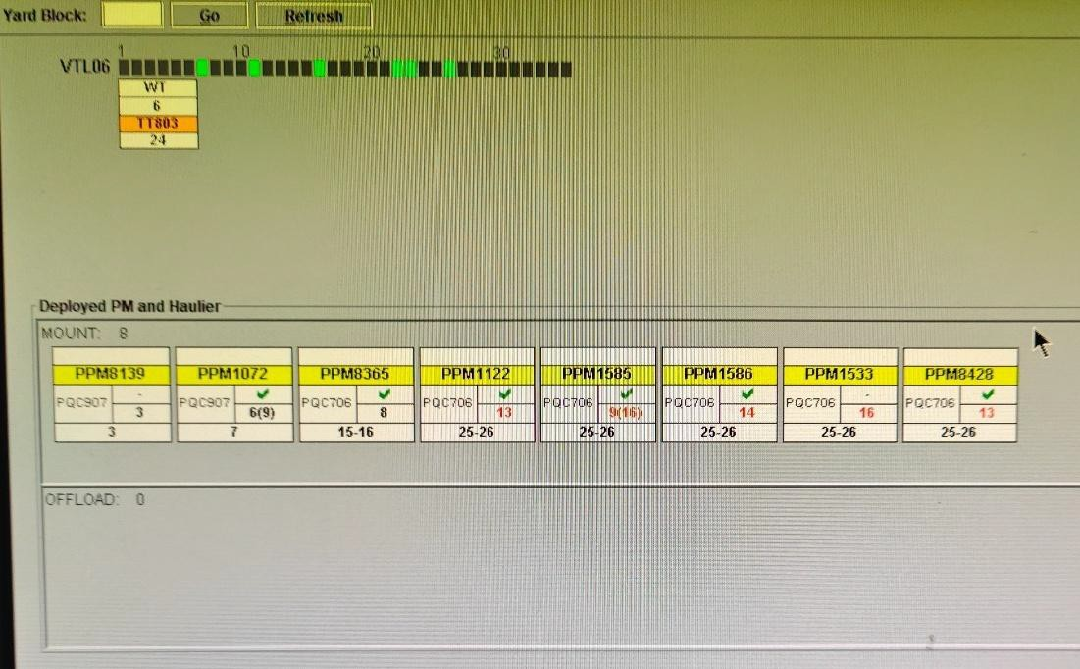

# 5: Reefer Mounting Job, Not Unplug

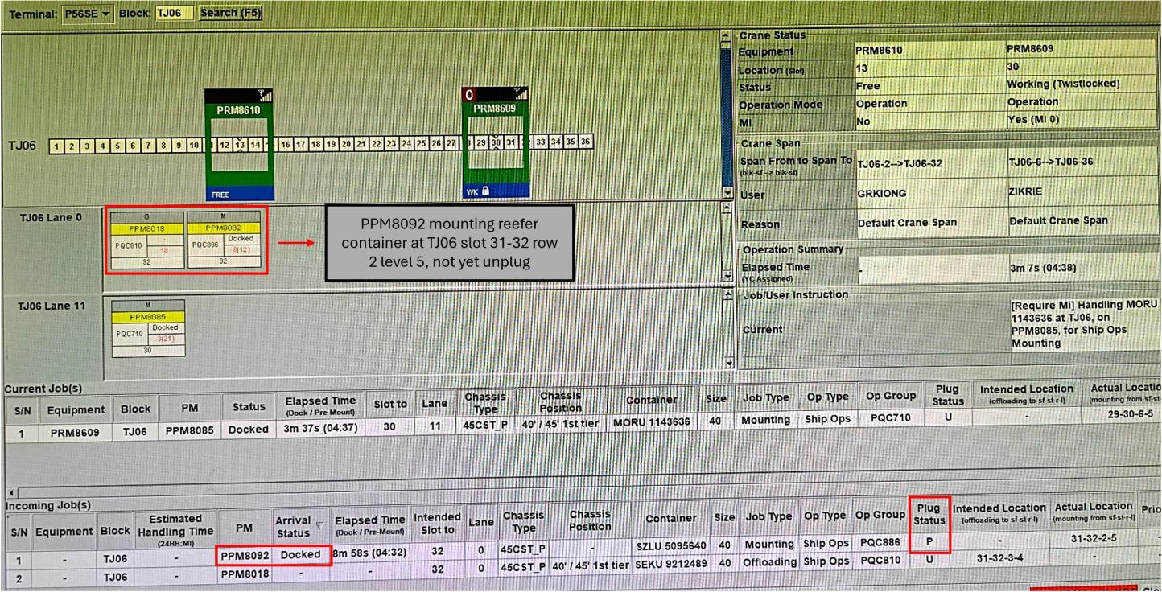

# Referring to block TJ06 above, PPM8092 was assigned for reefer mounting, but the container remains plugged in. Please advise on the necessary action to enable PPM8018 to proceed with offloading.